VEGAN CHOCOLATE MOUSSE  COOK TIME: 3h 20m  SOURCE:  #chocolate #quick #comfort-food | 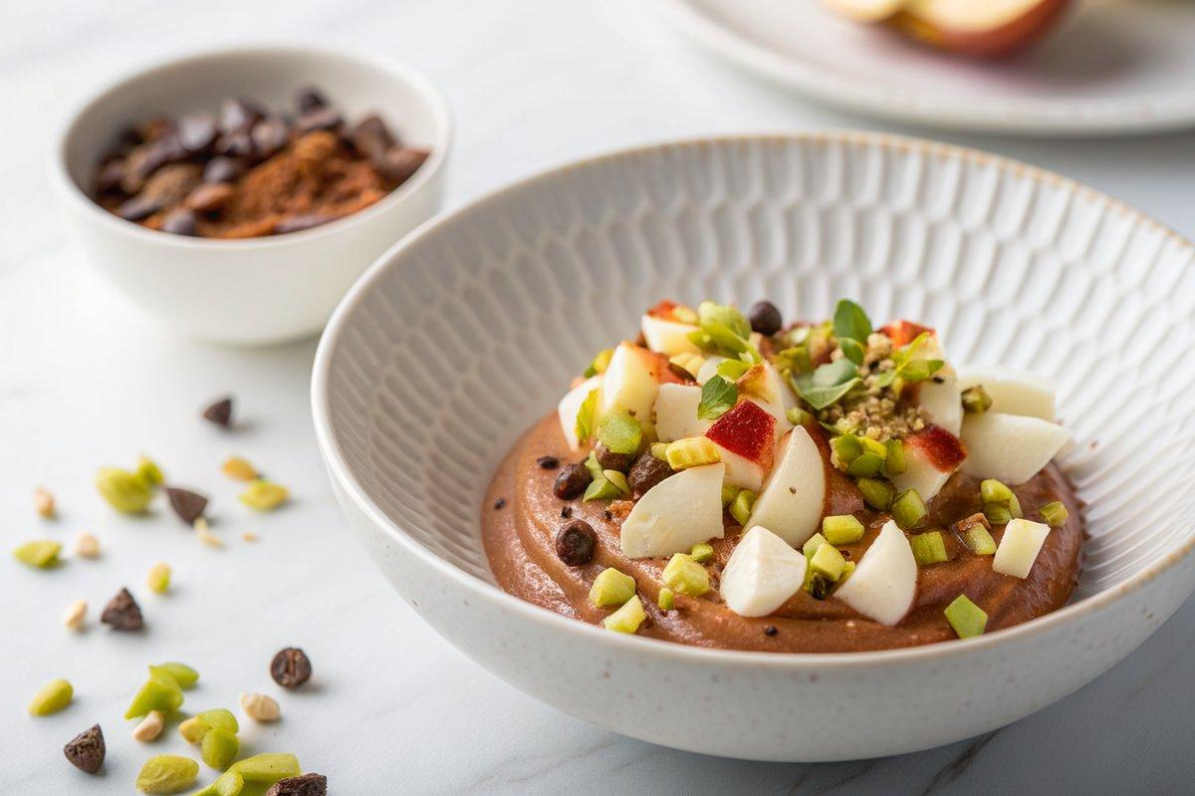

INGREDIENTS  - 1 lb (3 to 4) apples, (peeled, cored, and diced)  - 1 cup (240ml) roughly chopped pistachios  - 1 cup (8 oz) dark chocolate chips (at least 70% cacao)  - 1 tbsp extra virgin olive oil | PREP  COOK  1. Cook the apples. In a medium saucepan, add the apple chunks and about ¼ cup water over medium-high heat. Simmer, adjusting the heat as necessary, until the apples are super tender, about 15 minutes.  2. Prep the pan. While the apples cook, line a loaf pan with parchment paper, leaving the edges out on all sides so you can lift the mousse out of the pan using the sides of the parchment paper. Spread the pistachios over the parchment in the bottom of the pan.  3. Melt the chocolate. Add the chocolate and extra virgin olive oil to a medium heat-safe bowl. About 3 to 4 minutes before the apples are ready, place the bowl on top of the saucepan with the apple (you’ll use the steam from the apples to melt the chocolate). Stir the chocolate until fully melted and smooth.  4. Blend. Drain the apples and add them to the bowl of a food processor fitted with an S blade. Pour in the melted chocolate. Puree until the mixture is smooth; there may still be a bit of texture, which is fine. Pour the apple and chocolate mixture into the prepared pan.  5. Chill and serve. Refrigerate the mixture for at least 3 hours or overnight. When the mixture has hardened slightly to a mousse or pudding consistency, it is ready! Carefully remove it from the pan using the parchment paper on both sides. Flip it onto a plate and peel the parchment away to serve.  PLATING

