CRANBERRY ORANGE MUFFINS  COOK TIME: 23 min  SOURCE:  #quick #comfort-food #baking | 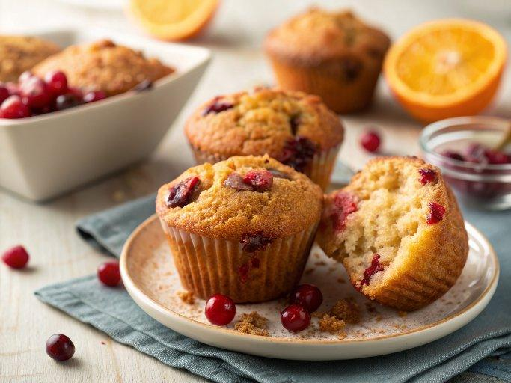

INGREDIENTS  - 1/3 cup (67 g) packed light or dark brown sugar  - 1 tbsp (15 g) granulated sugar  - 1/2 tsp ground cinnamon  - 1/4 cup (4 Tbsp; 56 g) unsalted butter, melted  - 2/3 cup (83 g) all-purpose flour (spooned & leveled)  - 1 and 3/4 cups (219 g) all-purpose flour (spooned & leveled)  - 1 tsp baking soda  - 1 tsp baking powder  - 1/2 tsp ground cinnamon  - 1/2 tsp salt  - 1/2 cup (8 Tbsp; 113 g) unsalted butter, softened to room temperature  - 1/2 cup (100 g) granulated sugar  - 1/4 cup (50 g) packed light or dark brown sugar  - 1 tbsp orange zest (from about 2 oranges)  - 2 large eggs, at room temperature  - 1/2 cup (120 g) plain yogurt or sour cream, at room temperature*  - 2 tsp pure vanilla extract  - 2 tbsp (30 ml) fresh orange juice  - 2 tbsp (30 ml) milk (any kind), at room temperature  - 1 and 1/2 cups (185 g) fresh or frozen cranberries (do not thaw)  - optional: coarse sparkling sugar, for sprinkling on top (if not using crumb topping)  - 1 cup (120 g) confectioners’ sugar  - 2 tbsp (30 ml) fresh orange juice | PREP  COOK  1. Preheat oven to 425°F (218°C). Spray a 12-count muffin pan with nonstick spray or line with cupcake liners. Set aside.  2. Make the crumb topping  3. Mix the brown sugar, granulated sugar, cinnamon, and melted butter together in a small bowl until combined. Add the flour and use a fork to gently mix until crumbs form. Don’t over-mix into a paste. Just mix until it is crumbly. Place in the refrigerator while you make the muffin batter. Cold crumbs hold shape better when baking.  4. Make the muffins:  5. Whisk the flour, baking soda, baking powder, cinnamon, and salt together in a medium bowl. Set aside.  6. In a large bowl using a handheld or stand mixer fitted with a paddle attachment, beat the butter, granulated sugar, and brown sugar together on high speed until smooth and creamy, about 3 minutes. Scrape down the sides of the bowl as needed. (Here’s a helpful tutorial if you need guidance on how to cream butter and sugar.) Add the orange zest and beat on medium speed for 1 minute. Add the eggs, yogurt/sour cream, and vanilla, and beat for 1 minute, then turn up to high speed until the mixture is combined and mostly creamy. (It’s ok if it appears somewhat curdled.) Scrape down the sides of the bowl as needed.  7. With the mixer on low speed, add the dry ingredients, orange juice, and milk, and beat until no flour pockets remain. Gently fold in the cranberries. Avoid over-mixing. Batter is thick.  8. Spoon the batter into prepared muffin cups, filling them all the way to the top. Spoon crumb topping on each, gently pressing it down so it sticks. If not using crumb topping, sprinkle muffins evenly with coarse sugar.  9. Bake for 5 minutes at 425°F (220°C); then, without opening the oven, reduce the oven temperature to 350°F (177°C). Bake for an additional 16–19 minutes or until a toothpick inserted in the center comes out clean. The total time these muffins take in the oven is about 21–24 minutes. (Usually closer to 21 minutes if you’re skipping the crumb topping.)  1  0. Allow the muffins to cool for 5 minutes in the muffin pan, then transfer to a wire rack to continue cooling. Let them cool for at least 15 minutes before icing.  1  1. Make the icing  1  2. Whisk the confectioners’ sugar and orange juice together and drizzle over warm or cooled muffins.  1  3. Iced or plain muffins stay fresh covered at room temperature for a few days or in the refrigerator for up to 1 week.  PLATING

