BEEF & POTATO PASTIES  COOK TIME: 1h  SOURCE:  #comfort-food #savory #homemade | 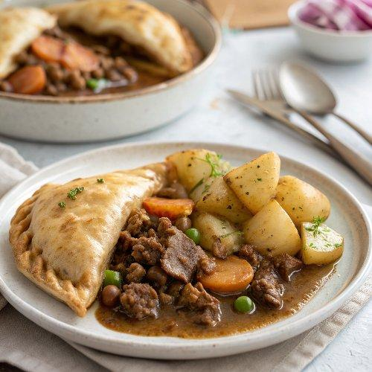

INGREDIENTS  - 200 g strong white flour, plus extra for dusting  - 100 g unsalted butter (cold)  - 20 ml milk, plus 1 tbsp for brushing  - 1 small onion  - 1 small all-rounder potato (135 g)  - 1 carrot (80 g)  - 200 g minced beef  - 3 tbsp brown sauce  - 1 tsp white pepper  - 1 tsp dried thyme  - 2 little gem lettuces  - 3 sticks of celery  - 1 eating apple  - 1 tsp English mustard  - red wine vinegar  - olive oil | PREP  COOK  1. Tip the flour into a bowl with a pinch of sea salt, then chop and rub in the butter. Make a well in the middle, slowly pour in 20ml of milk, then mix, pat and bring it all together – add a little more milk if it feels too dry.  2. Divide the dough in half and pat into 2 thick flat rounds. Wrap in greaseproof paper and chill in the fridge for 30 minutes.  3. Preheat the oven to 180°C/350°F (175°C)/gas  4. Line a large baking tray with greaseproof paper and lightly dust with flour.  4. Peel the onion and wash the potato and carrot. Using a box grater, coarsely grate them into a bowl along with the mince, brown sauce, white pepper, ½ teaspoon of thyme and a good pinch of salt. Scrunch well with clean hands.  5. Roll out each round of pastry into a 24cm (9-inch) round on a clean, flour-dusted surface. Divide the filling between them, piling it to one side of the middle, leaving a 2.5cm (2-inch) gap around the edges.  6. Lightly brush the exposed pastry with milk, fold over and press the edges down, then twist and crimp with your fingers and thumbs to seal. Brush with the remaining milk, slash the top a couple of times with a sharp knife, then place on the tray and bake for 40 minutes, or until golden.  7. Click off the outer lettuce leaves (save them for another day), then quarter the lettuce lengthways. Trim the celery and roughly chop into chunks, and core the apple and cut into 8 wedges.  8. In a large serving bowl, whisk the mustard, 1 tablespoon of red wine vinegar and 2 tablespoons of olive oil, then season to perfection. Toss the salad in the dressing at the last minute, then serve with the warm pasties.  PLATING

