EPIC LAMB KEBABS  COOK TIME: 1h 30m  SOURCE:  #grilled #comfort-food #meat | 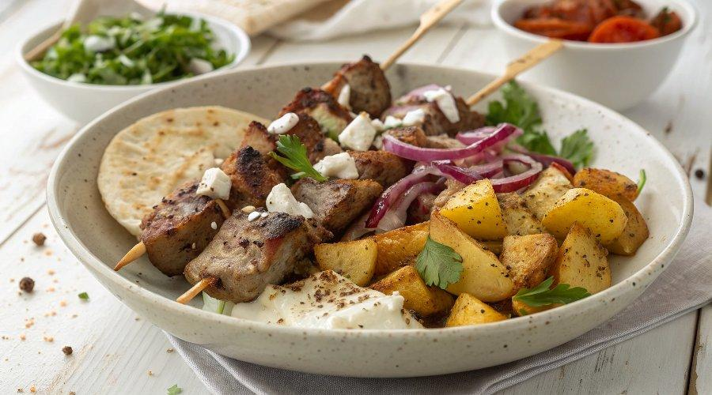

INGREDIENTS  - 1.4 kg lamb shoulder, bone out  - 2 cloves of garlic  - 3 lemons  - 1 heaped tbsp dried oregano, ideally the flowering kind  - 100 g feta cheese  - 150 g natural yoghurt  - 1/2 tsp smoked paprika  - 1.6 kg Maris Piper potatoes  - 1 tsp dried oregano, ideally the flowering kind  - olive oil  - FLATBREADS (makes 8)  - 350 g self-raising flour, plus extra for dusting  - 350 g natural yoghurt  - 1 red onion  - 1 large ripe tomato  - 1 cucumber  - 1/2 a white cabbage (400 g)  - 1 tbsp white wine vinegar  - extra virgin olive oil | PREP  COOK  1. Preheat the oven to 200ºC/400ºF/gas  6.  2. Score a criss-cross pattern into any fat on the lamb, then cut into 2cm (1-inch)-thick slices.  3. Peel the garlic and finely grate over the lamb with the zest of 1 lemon, then squeeze over its juice. Sprinkle over the oregano and season with a big pinch of sea salt and black pepper. Rub all over the meat, then cover and marinate in the fridge for 30 minutes.  4. For the chips, scrub the potatoes and slice into 1.5cm (2-inch)-thick chips, then parboil in a pan of boiling salted water for 6 to 8 minutes. Drain in a colander, leave to steam dry for 2 minutes, then lightly shake the colander to chuff up the chip edges.  5. Divide between two baking trays, then season from a height with salt, pepper and the dried oregano. Drizzle each tray with 2 tablespoons of olive oil and toss to coat. Roast in a single layer for 35 to 40 minutes, or until golden and crisp, turning halfway.  6. To make the flatbreads, mix the flour, yoghurt and a pinch of salt together into a dough. Knead on a clean flour-dusted surface for 1 minute to bring it all together, then roll into 8 balls. Cover with a damp cloth.  7. Thread the lamb on to a long, sturdy metal skewer to make one epic kebab (or split between two, if you prefer).  8. Preheat a large griddle or barbecue to high, then cook the lamb for 15 minutes, or until dark and gnarly all over, turning regularly. Transfer to a large baking tray and roast in the oven for 5 minutes, or until just cooked through but still slightly blushing.  9. For the salad, peel and coarsely grate the red onion with the tomato, cucumber and cabbage. Drizzle over the vinegar and 2 tablespoons of extra virgin olive oil, season to perfection, then toss together.  1  0. Roll the flatbreads out on a clean flour-dusted surface into ½cm-thick rounds. Reduce the heat under the griddle to medium and – in batches – cook the flatbreads for 1 minute each side, or until charred.  1  1. To serve, shave the meat off the kebab, drizzling over any resting juices (see tip below). On a plate, drizzle the feta with a little extra virgin olive oil. Put the yoghurt into a bowl and sprinkle over the paprika. Cut the remaining lemons into wedges.  1  2. Serve it all in the middle of the table and let your guests get stuck in!  PLATING

