ONE POT MEDITERRANEAN CHICKEN  COOK TIME: 35 min  SOURCE:  #one-pot #comfort-food #chicken | 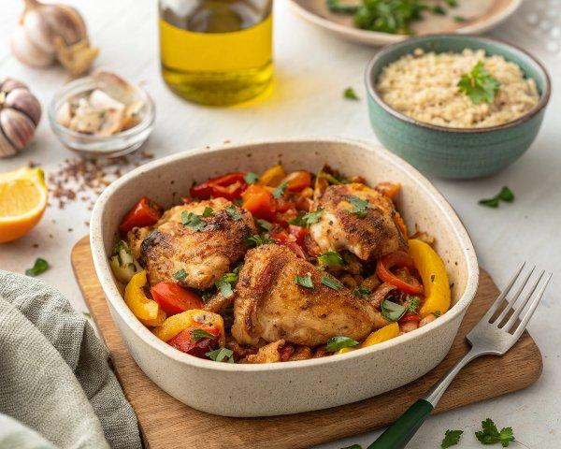

INGREDIENTS  - 4 bone in, skin on chicken thighs  - 2 tsp olive oil  - 1 small onion ( finely diced)  - 2 cloves garlic (minced)  - 1/2 cup roasted peppers (roughly chopped (can use red, yellow or orange peppers)  - 8 oz orzo pasta (uncooked)  - 3/4 cup kalamata olives (halved)  - 1/2 tsp dried oregano  - 15 oz can chickpeas (drained and rinsed)  - 3 cups (720ml) chicken broth  - kosher salt and black pepper (to taste)  - 2 tbsp fresh parsley (chopped) | PREP  COOK  1. Preheat oven to 375 degrees. In a large skillet or pot, heat the olive oil over medium high heat. Season the chicken generously on both sides with salt and pepper. Place the chicken in the pan and cook for 4 to 6 minutes on each side or until golden brown. Remove the chicken from the pan.  2. Drain off excess fat leaving about 1 teaspoon in the pan. Add the onion, cook for 5 minutes. Add the garlic, cook for one minute more.  3. Add the orzo, oregano, roasted peppers, olives and chickpeas to the pan. Season with 1/2 teaspoon salt and 1/4 teaspoon pepper. Place the chicken on top of the orzo mixture; add chicken broth.  4. Bring everything to a boil, cover the pot with a lid and place into the oven. Bake for 35 minutes or until chicken is cooked through. Sprinkle with parsley, then serve.  PLATING

