AMBODE RECIPE (KARNATAKA STYLE MASALA VADA)  COOK TIME: 1h  SOURCE:  #crispy #spicy #snack | 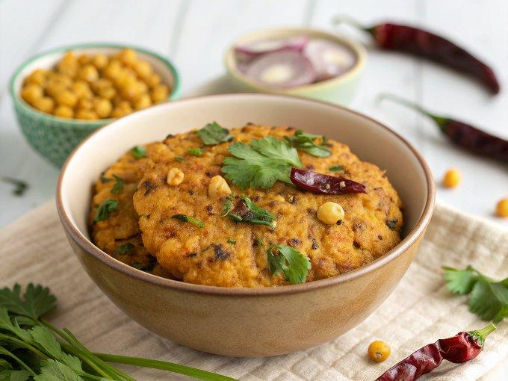

INGREDIENTS  - 1 cup (240ml) Chana dal (Bengal g Dal)  - 1/2 cup Dill leaves chopped  - 1/4 cup Coriander (Dhania) Leaves chopped  - 1 Onion finely chopped  - 6 to 7 Green Chillies adjustable  - 1-inch (3cm) Ginger finely chopped  - 3 tbsp Rice flour  - Salt as required  - 1/2 tsp Turmeric powder (Haldi)  - pinch Asafoetida (hing)  - Oil for deep frying | PREP  COOK  1. To begin making the Ambode recipe, soak Chana Dal in water for about 4 hours or overnight.  2. Wash the dal thoroughly and grind soaked dal without water into a coarse paste.  3. In a bowl, add grounded dal, chopped onion, green chilies, turmeric powder, salt, hing, dill leaves and coriander leaves. Combine them together.  4. Season it with salt. Make small balls out of the dough.  5. In a wok/kadai, add oil and heat it over the medium flame.  6. Take a ball in your hand and press them with your hand into small round circles.  7. Once the oil is hot, add the circles into it and fry until both the sides turn golden in colour.  8. Ensure you fry the vada over medium heat. Repeat the same for the remaining balls.  9. Serve Ambode along with Tomato Garlic chutney, Tomato chutney or any other chutney of your choice.  PLATING

