KAZUNOKO (HERRING ROE)  COOK TIME: 5 min  SOURCE:  #seafood #traditional #Japanese | 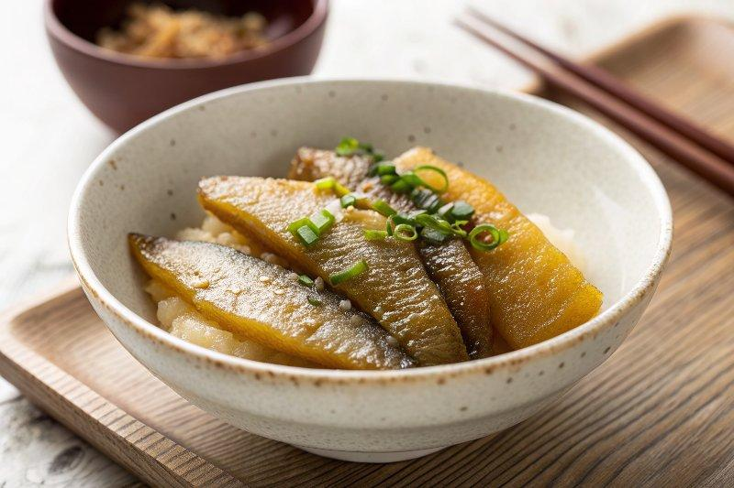

INGREDIENTS  - 5 pieces salted herring roe (4.9-7 oz, 140-200 g for five pieces)  - 6 cups (1440ml) water (divided into thirds)  - 3 tsp Diamond Crystal kosher salt (divided into thirds)  - 2 Tbsp sake  - 1 Tbsp mirin  - 1 cup (240ml) dashi (Japanese soup stock) (I used Awase Dashi, made with a combination of kombu and katsuobushi; in a pinch, substitute a Dashi Packet or Dashi Powder)  - 2 Tbsp usukuchi (light-colored) soy sauce (you can use regular soy sauce)  - 1 Tbsp katsuobushi (dried bonito flakes) (1 Tbsp is 1.5 g)  - katsuobushi (dried bonito flakes) | PREP  COOK  1. Before You Start...  2. Please note that this recipe requires a soaking time of 6 hours and an overnight marinating time. If you will include this dish in your Osechi meal, I recommend preparing it up to 4 days before you plan to serve. For more helpful tips on planning your Japanese New Year feast, please read my A 5-Day Osechi Cooking Timeline blog post.  3. Gather all the ingredients.  4. To Desalinate the Roe  5. Combine one-third of the water (2 cups, 480 ml) and salt (1 tsp) in a measuring cup and mix well until the salt is completely dissolved.  6. Place 5 pieces salted herring roe in a dish with a rim (a pound cake pan is perfect). Then, pour the salted water into the dish or pan and let it soak for 2 hours to desalinate the roe.  7. Discard the salt water in the dish. Make a new batch of salt water with another one-third of the water and salt. Soak the roe again for another 2 hours. Repeat one more time. Once you finish the three rounds of soaking in salt water (6 hours total), taste a bit of the salted herring roe to see how salty it is. It should be slightly salty but taste good as is. If it’s still too salty, continue with one more round of desalinating.  8. To Make the Marinade  9. Meanwhile, heat up 2 Tbsp sake and 1 Tbsp mirin in a small saucepan. Let the alcohol evaporate until the smell of alcohol is gone.  1  0. Then, add 1 cup (240ml) dashi (Japanese soup stock) and 2 Tbsp usukuchi (light-colored) soy sauce and bring to a boil.  1  1. Once boiling, add 1 Tbsp katsuobushi (dried bonito flakes). Turn off the heat and let stand for 1 minute.  1  2. Strain the marinade into a bowl or glass measuring cup and discard the katsuobushi. Set aside to cool.  1  3. To Remove the Membrane  1  4. Remove the herring roe from the salt water. Using your thumb and index finger, rub and press the membrane to collect it toward the center of the roe. Once the membrane is collected around the center and you have enough to pinch and pull, gently detach the membrane from the roe. Make sure to remove the membrane on both sides.  1  5. Wash the herring roe thoroughly and pat dry with paper towels.  1  6. To Marinate  1  7. Transfer the herring roe into a container and soak in the marinade overnight or up to 2 days.  1  8. To Serve  1  9. Tear the Kazunoko into bite-size pieces and put inside an Osechi box or serving plate/bowl. You can sprinkle some katsuobushi (dried bonito flakes) on top before serving.  2  0. To Store  2  1. Store it in an airtight container and keep in the refrigerator for up to 3–4 days.  PLATING

