CHIPOTLE SHRIMP BURRITO BOWLS  COOK TIME: 5 min  SOURCE:  #quick #comfort-food #grilled | 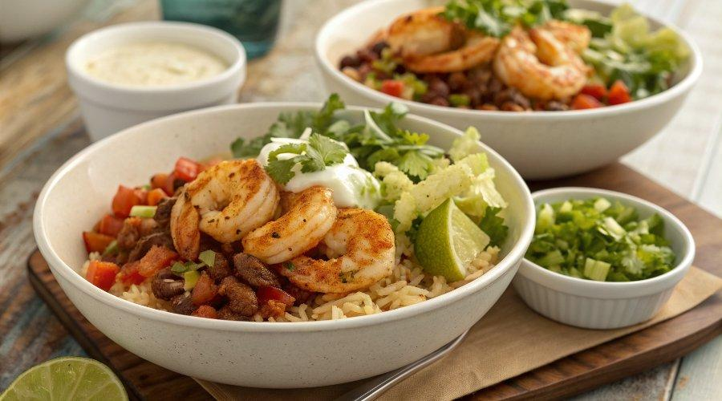

INGREDIENTS  - 1 lb. large shrimp (approximately 24 shrimp) (deveined and peeled)  - 2 tbsp, plus 2 tsp olive oil (divided)  - 3 tbsp fresh lime juice (about 1 medium lime)  - 1-2 chipotle peppers in adobo sauce (finely minced (about 1/-2-1 tbsp)  - 1 tsp adobo sauce (liquid from can of peppers)  - 2 garlic cloves (minced)  - 2 tsp honey  - 3/4 tsp ground cumin  - 1/2 tsp kosher salt  - 1/4 tsp cayenne pepper  - 4 cups (960ml) cooked rice (white, brown or cauliflower)  - 1 15 oz. can black beans (rinsed, drained and warmed)  - 1-2 fresh tomatoes (diced or 1 cup halved cherry tomatoes)  - 1-2 large avocados (thinly sliced)  - Fresh sweet corn from 2 cobs  - 4 green onions (thinly sliced)  - 1-2 tbsp finely minced fresh cilantro  - Lime wedges for serving  - 1/2 Recipe Cilantro Lime Dressing (or sour cream/Greek yogurt - something creamy) | PREP  COOK  1. Stir together 2 tablespoons of oil and all remaining “Shrimp” ingredients in a freezer size plastic bag or an airtight container. Add shrimp, seal tightly and turn to coat. Let the shrimp rest on the counter for 15 minutes.  2. Heat a large stainless steel pan over medium-high heat. Add the remaining 2 teaspoons of olive oil to the pan and swirl to coat.  3. Add shrimp in a single layer and discard any remaining marinade. Let shrimp cook for 2 minutes then turn over and cook an additional 1 minute or until they’re pink. Increase the heat to high for 30-60 seconds to slightly reduce any liquids. Remove shrimp from the pan when they’re finished cooking.  4. Divide rice between 4 bowls and top with shrimp and other desired Burrito Bowl ingredients. Drizzle with Cilantro Lime Dressing. Shrimp can also be served on top of a salad or in wraps.  PLATING

