DOPIAZEH ALOO (PERSIAN POTATO CURRY)  COOK TIME: 40 min  SOURCE:  #comfort-food #curry #spicy | 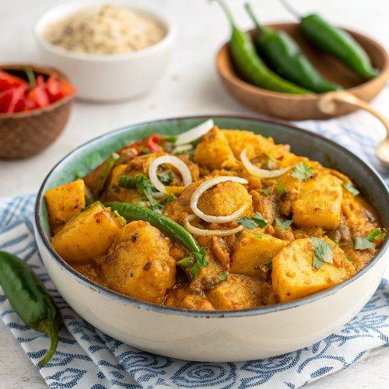

INGREDIENTS  - 2 lb Yukon gold potatoes, (peeled and sliced into 2-3-inch cubes)  - Kosher salt  - 2 tbsp extra virgin olive oil  - 2 yellow onions, (thinly sliced)  - 1 large green bell pepper, (thinly sliced)  - 4 garlic cloves, (crushed or finely minced)  - 1 (2-inch) piece ginger, (peeled and finely grated)  - 1 red chili, (deseeded and finely minced)  - 1 tsp turmeric powder  - 1 tsp ground cumin  - 1 tsp ground coriander  - 2 medium tomatoes, (chopped)  - 1 tbsp tomato paste (optional)  - 1 tbsp fresh lime juice (optional)  - Black pepper  - 1 small bunch of cilantro, (finely chopped) | PREP  COOK  1. Prepare and boil the potatoes. In a large saucepan, add the potatoes and cover with water. Salt the water generously and bring to a boil over high heat. Cover the pan with a lid and cook for 10 minutes, or until the potatoes are just tender. Drain and set aside.  2. Cook the onions and green bell pepper. In the same pan used to boil the potatoes, add the olive oil and set the pan over medium-high heat. Once the oil begins to shimmer, add the onion and saute, stirring until they have softened and started to caramelize, about 8 minutes. Then add the bell pepper and cook, stirring until it has softened slightly, about 3 minutes.  3. Add the fresh aromatics. Add the garlic, ginger, and red chili. Stir until the aromatics are released, about 1 minute.  4. Add the spices. Add the turmeric, cumin and coriander. Stir to coat the onion and pepper mixture.  5. Add the tomatoes. Add the chopped fresh tomatoes and stir gently until they soften and break down, about 3 minutes.  6. Add the tomato paste and water. Add the tomato paste and stir into the mixture, then add 1 cup (240ml) of water to create a light sauce.  7. Add potatoes, lime juice and seasoning. Stir in the drained potatoes and turn the heat to medium-low. Add the fresh lime juice (if using) and season with salt and pepper to taste. Stir the mixture gently until evenly mixed. Cover and gently cook for approximately 15 minutes for the flavors to marry. Stir now and again and lower heat further, if necessary.  8. Garnish and serve. Turn the heat off. Gently stir in 3/4 of the cilantro. Spoon into a serving dish and sprinkle with the remaining cilantro if you’d like. Serve immediately.  PLATING

