BACON WRAPPED SCALLOPS  COOK TIME: 15 min  SOURCE:  #seafood #bacon #grilled | 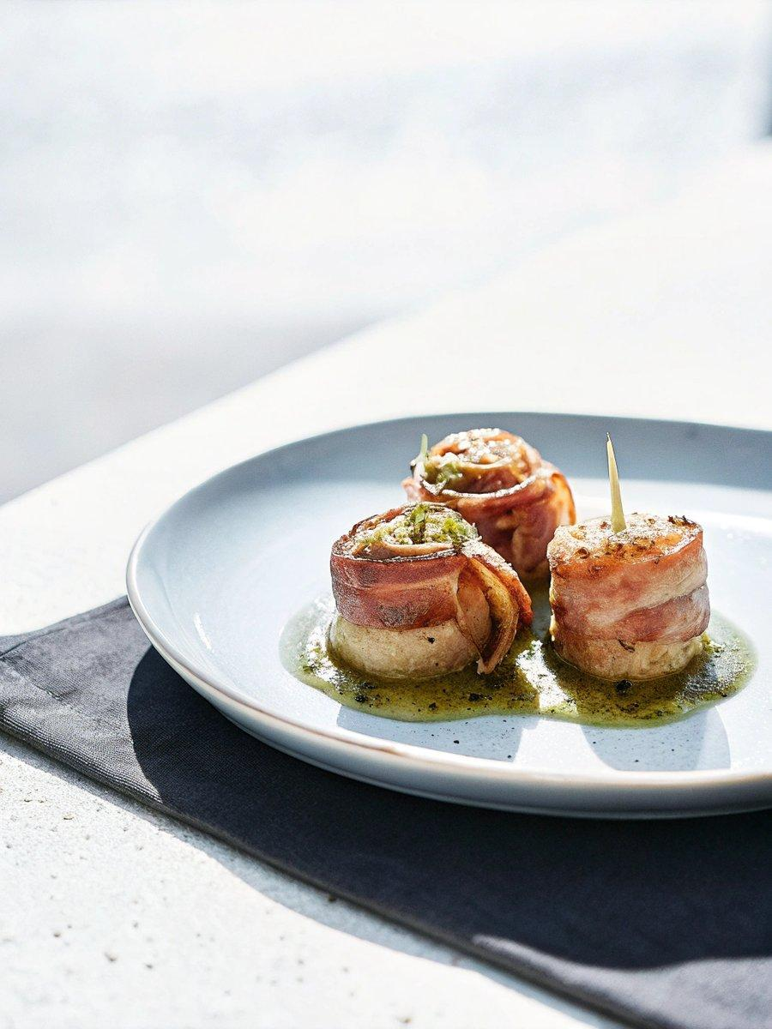

INGREDIENTS  - 16 large sea scallops (about 1 lb/450 g)  - 1/4 tsp salt  - 1/4 tsp ground black pepper  - 8 slices bacon (cut in half crosswise (224 g) | PREP  COOK  1. Preheat oven to 425°F (220°C).  2. Grease a large baking sheet and set aside.  3. Pat the scallops dry with a paper towel. Sprinkle all over with salt and pepper. Wrap a piece of bacon around the side of each scallop and secure it with a toothpick.  4. Place the wrapped scallops about 2-inch (5cm) apart on the prepared baking sheet.  5. Bake for 15 minutes or until the scallops are opaque and bacon is cooked.  PLATING

