DEB'S KALE SALAD WITH APPLE, CRANBERRIES AND PECANS  COOK TIME: 5 min  SOURCE:  #healthy #quick #fresh | 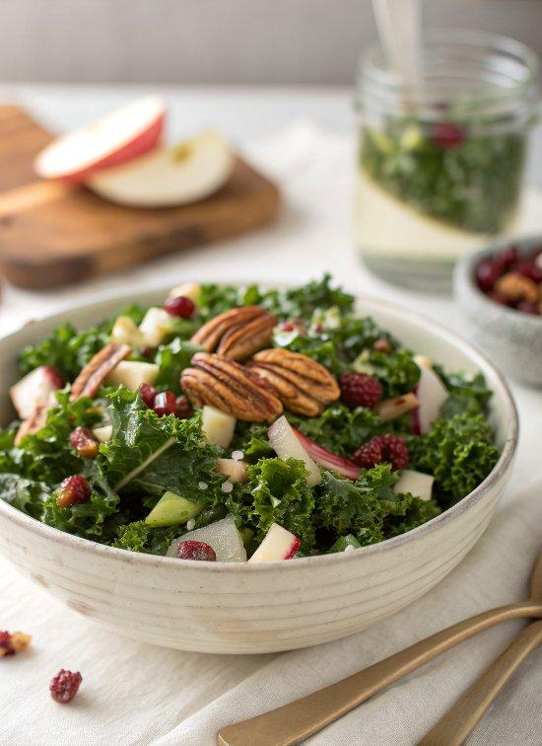

INGREDIENTS  - 1/2 cup pecan halves  - 8 oz kale (I used regular curly green kale, but Deb recommends Cavolo Nero or Lacinato, Dinosaur or Tuscan Kale)  - 4 to 5 medium radishes  - 1/2 cup dried cranberries or dried cherries  - 1 medium Granny Smith apple  - 2 oz soft goat cheese, chilled  - 3 tbsp olive oil  - 1 1/2 tbsp apple cider vinegar or white wine vinegar  - 1 tbsp smooth Dijon mustard  - 1 1/2 tsp honey or maple syrup  - Salt and freshly ground pepper, to taste | PREP  COOK  1. Preheat the oven to 350 degrees and spread the pecans on a baking tray. Toast them until lightly golden and fragrant, about 5 to 10 minutes, tossing them once or twice to make sure they bake evenly. Remove the tray from the oven and set them aside to cool.  2. Pull the kale leaves off from the tough stems and discard the stems. Use a chef’s knife to chop the kale into small, bite-sized pieces. Transfer the kale to a big salad bowl. Sprinkle a pinch of salt over the kale and massage the leaves with your hands by lightly scrunching big handfuls at a time until the leaves are darker in color and fragrant.  3. Thinly slice the radishes (this is easier to do if you first chop off the root end so you can place the base of the radish flat against your cutting board). Add them to the bowl.  4. Coarsely chop the pecans and cranberries and add them to the bowl. Chop the apple into small, bite-sized pieces and add it to the bowl. Use a fork to crumble the goat cheese over the top.  5. In a small bowl, whisk the dressing ingredients together and pour the dressing over the salad. Toss until the salad is evenly coated with dressing. Serve immediately, or for even better flavor, let the salad marinate for 10 to 20 minutes beforehand. This salad keeps well in the refrigerator, covered, for up to 4 days.  PLATING

