BLUEBERRY MAPLE BRAN MUFFINS  COOK TIME: 30 min  SOURCE:  #quick #healthy #baking | 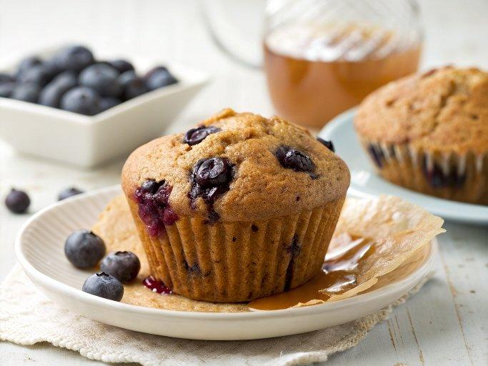

INGREDIENTS  - 1 cup (240ml) plus 2 tsp all-purpose flour, (spooned into measuring cup and leveled-off, divided)  - 3/4 cup whole wheat flour, (spooned into measuring cup and leveled-off)  - 1/3 cup wheat bran or wheat germ  - 1 1/4 tsp baking powder  - 1/4 tsp baking soda  - 1/2 tsp salt  - 1 tsp cinnamon  - 2 large eggs  - 1/4 cup pure maple syrup  - 2/3 cup sugar  - 1/2 cup vegetable oil  - 1 cup (240ml) milk  - 1 cup (240ml) fresh blueberries | PREP  COOK  1. Preheat the oven to 350°F (175°C) and set an oven rack in the middle position. Grease a standard 12-cup muffin tin with non-stick cooking spray.  2. In a large bowl, whisk together the 1 cup (130 g) of the all-purpose flour, the wheat flour, wheat bran (or wheat germ), baking powder, baking soda, salt, and cinnamon.  3. In another bowl, beat together the eggs, maple syrup, sugar, oil and milk. Whisk the egg mixture into the flour mixture until batter is smooth (note: batter will be very wet).  4. Rinse the blueberries and toss them in a small bowl with the remaining 2 teaspoons of flour until they are well-coated (the blueberries need to be wet in order for the flour to stick). Add them to the batter and fold gently with a spatula until evenly distributed. Using a ladle or ⅓-cup measure, scoop the batter into the muffin cups until they are almost full.  5. Bake for 25 to 30 minutes, until golden brown and crisp around the edges. Cool in the pan for 5 minutes, then turn muffins out onto a wire rack. Serve warm. Store leftover muffins in an airtight container at room temperature for up to 2 days and reheat before serving. (To reheat, wrap muffins in aluminum foil and place in a 350°F/175°C oven for 10 to 15 minutes.)  PLATING

