SIMPLE ARRABBIATA  COOK TIME: 20 min  SOURCE:  #quick #comfort-food #pasta | 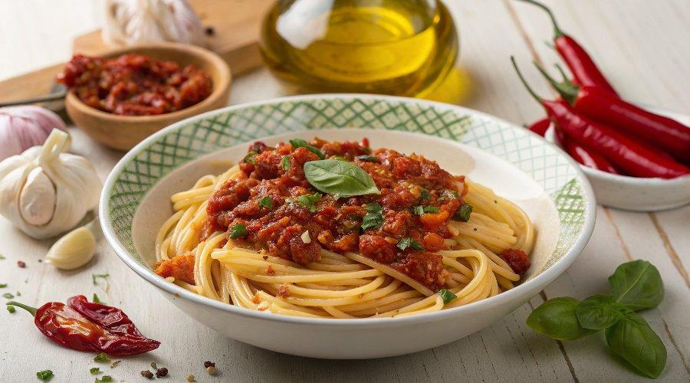

INGREDIENTS  - 1 fresh red chilli  - olive oil  - 2 cloves of garlic  - 1 pinch of dried chilli flakes  - 2 x 400 g tins of chopped tomatoes  - 320 g dried spaghetti  - a few fresh baby basil leaves | PREP  COOK  PLATING

