KARWAR STYLE MUGA AMBAT RECIPE (MOONG SPROUTS IN COCONUT CURRY)  COOK TIME: 15 min  SOURCE:  #curry #comfort-food #healthy | 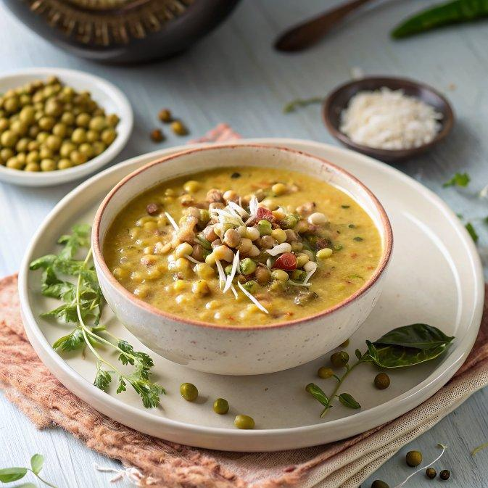

INGREDIENTS  - 1 cup (240ml) Green Moong Sprouts  - 1 tbsp Tamarind Paste  - 1/4 tsp Turmeric powder (Haldi)  - 1/2 tsp Sugar  - Salt to taste  - 1/2 cup Fresh coconut grated  - 2 Dry Red Chillies  - 1 tsp Coriander (Dhania) Seeds  - 1 tsp Oil  - 1 tsp Mustard seeds (Rai/ Kadugu)  - Asafoetida (hing) a pinch  - 3-4 Curry leaves torn | PREP  COOK  1. To prepare Karwar Style Muga Ambat Recipe (Moong Sprouts in Coconut Curry), remove the skin of the green gram/moong sprouts by soaking them in water for 20 minutes and then rubbing off with hands.  2. One the moong sprouts are ready, heat a kadai/wok with oil and temper with mustard and curry leaves.  3. Add the onions, sugar and a pinch of salt and keep stirring over low heat till the onions turn brown.  4. Now add the sprouted green gram, tamarind pulp, turmeric powder and mix well and cook them covered over low flame for 5 minutes.  5. Open the lid and add 1 cup (240ml) of water to the mixture.  6. In a mixer grinder, combine the coconut along with the coriander seeds, salt and red chillies and grind this along with some water to make a thick coconut paste.  7. Adjust salt and stir in the thick coconut paste into the curry.  8. Mix Muga Ambat well and allow them to cook for another 3-4 minutes and switch off.  9. Serve Karwar Style Muga Ambat (Moong Sprouts in Coconut Curry) with Steamed rice or pooriand poriyal to enjoy your everyday meal.  PLATING

