HOMEMADE TRAIL MIX RECIPE WITH DRY FRUITS  COOK TIME: 30 min  SOURCE:  #healthy #quick #nutritious | 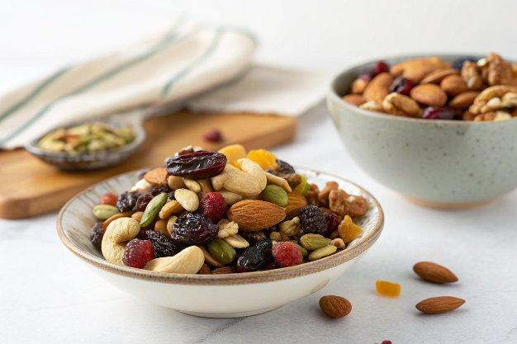

INGREDIENTS  - 1 cup (240ml) Walnuts quartered  - 1 cup (240ml) Whole Almonds (Badam) sliced  - 1 cup (240ml) Pistachios sliced  - 1/2 cup Sultana Raisins  - 1/2 cup Cranberries  - 1/2 cup Dates  - 1/2 cup Sunflower seeds | PREP  COOK  1. To begin making the Homemade Trail Mix Recipe with Dry Fruits, all you have to do is get all the ingredients ready.  2. Cut them into small bite size pieces and combine all of them together.  3. Store the Homemade Trail Mix in airtight glass jars so they stay fresh for a long time.  4. Serve Homemade Trail Mix Recipe as an after school snack to your kids along with Pineapple Banana & Oat Smoothie Recipe.  PLATING

