QUESO FUNDIDO  COOK TIME: 20 min  SOURCE:  #cheesy #spicy #comfort-food | 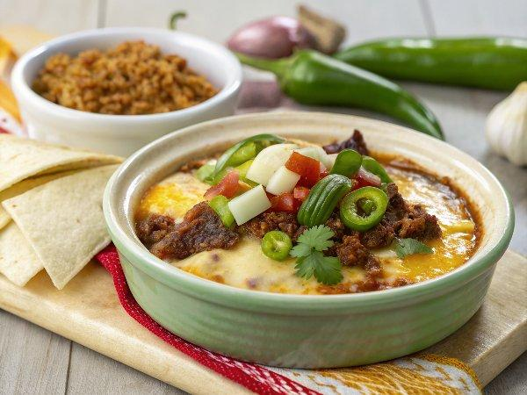

INGREDIENTS  - 8-9 oz. Mexican chorizo  - 1/2 large yellow onion (diced)  - 1 serrano chile pepper (seeded and diced)  - 2-3 garlic cloves (minced)  - 2 cups (480ml) freshly grated Monterrey or Oaxaca cheese (8 oz)  - 1 cup (240ml) freshly grated mozzarella or Oaxaca cheese (4 oz.)  - 1 cup (240ml) freshly grated sharp cheddar cheese (4 oz.)  - 1 tbsp flour  - 3/4 cup low sodium chicken broth  - 1/2 cup pinto beans (rinsed and drained)  - 1 15 oz. can tomatoes with green chiles (drained, (Rotel)  - 2 chopped Roma tomatoes  - 1/4 cup chopped green onions  - 2 tbsp chopped cilantro  - Tortilla Chips for serving | PREP  COOK  1. Preheat oven to 400°F (200°C).  2. Add cheese to a medium bowl and toss with flour. Set aside.  3. Heat a large cast iron skillet to medium-high heat. Add chorizo and cook and crumble for 5 minutes. Add onions and serrano pepper and cook until the chorizo is crisp and the onion is softened, 5-7 minutes. Add garlic and sauté 30 seconds. Drain off any excess fat and remove to a bowl (NOT the cheese bowl), do not wipe out the skillet.  4. Turn heat to the lowest setting and add chicken broth. Whisking constantly, add the cheese mixture a little bit at a time until melted and smooth. Stir in the beans, tomatoes, and chorizo mixture.  5. Bake at 400°F (200°C) until cheese is hot and bubbly BUT not hardened on the top, about 5-7 minutes. Garnish with tomatoes, green onions and cilantro. Serve immediately with tortilla chips.  PLATING

