SLOW COOKER LEMON FETA DRUMSTICKS  COOK TIME: 4h  SOURCE:  #slow-cooker #chicken #lemon #feta #comfort-food | 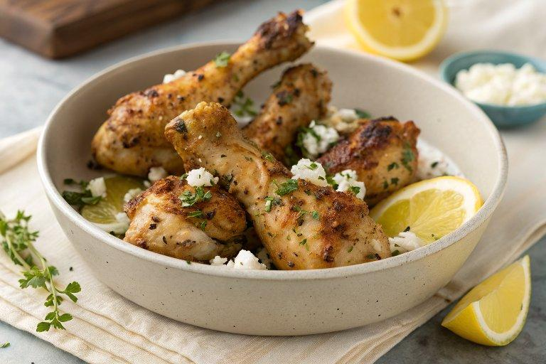

INGREDIENTS  - 8 skinless chicken drumsticks (about 30 oz total)  - • kosher salt and fresh ground pepper  - • 2 tsp garlic powder  - • 1 tbsp dried oregano  - • juice of 1 lemon  - • 1/3 cup feta cheese (fresh grated) | PREP  COOK  1. Season chicken with salt, pepper, garlic powder, oregano, and lemon juice.  2. Place in the slow cooker and cook on HIGH 4 hours, or until chicken is no longer pink in the center near the bone.  3. When chicken is cooked through, sprinkle with grated feta and cover until cheese is melted.  PLATING

