CHICKEN LO MEIN  COOK TIME: 15 min  SOURCE:  #quick #comfort-food #stir-fry | 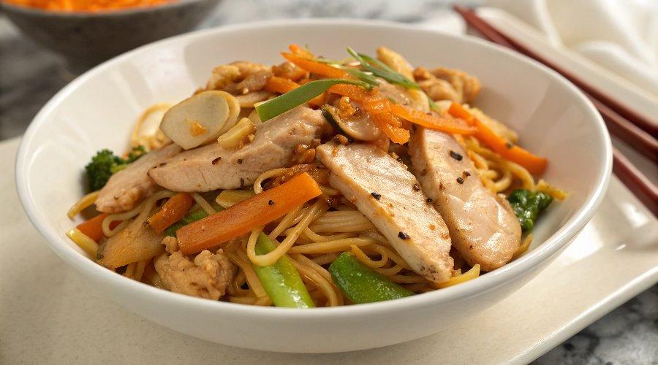

INGREDIENTS  - 1 tbsp vegetable oil  - 3/4 lb boneless skinless chicken breasts (cut into thin slices)  - 10 oz fresh egg noodles (pre-cooked)  - 1/2 cup thinly sliced yellow onion  - 1/2 cup shredded or julienned carrots  - 1/4 cup thinly sliced celery  - 1 cup (240ml) shredded cabbage  - 1 tsp minced garlic  - 1/4 cup chicken broth  - 2 tbsp hoisin sauce  - 2 tbsp soy sauce  - 1 tbsp sesame oil  - 2 tsp cornstarch  - 1/4 cup sliced green onion tops (only the dark green part)  - salt and pepper to taste | PREP  COOK  1. Preheat the oil in a large pan over medium high heat.  2. Add the chicken and season with salt and pepper to taste. Cook for 3-4 minutes per side or until golden brown.  3. Remove the chicken from the pan. Add the onions, carrots, celery and cabbage to the pan and cook for 3-4 minutes or until just softened.  4. Add the garlic and cook for 30 seconds.  5. Add the noodles to the pan, along with the chicken. Toss to combine.  6. In a small bowl, whisk together the chicken broth, hoisin sauce, soy sauce, sesame oil and cornstarch.  7. Pour the sauce into the pan and bring to a simmer. Cook for 1 minute or until sauce is thickened. Sprinkle with green onions, then serve.  PLATING

