SKILLET COOKIE  COOK TIME: 25 min  SOURCE:  #cookies #baking #comfort-food | 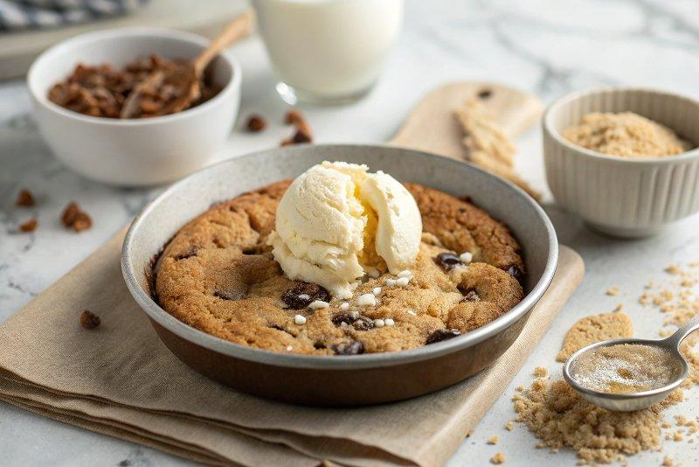

INGREDIENTS  - 2 cups (480ml) all-purpose flour (240 g)  - 1/2 tsp baking soda  - 1/2 tsp kosher salt  - 10 tbsp unsalted butter (softened (141 g)  - 1/2 cup firmly packed light brown sugar (110 g)  - 1/2 cup granulated sugar (100 g)  - 1 large egg  - 2 tsp vanilla extract  - 3/4 cup plus 2 tbsp semi-sweet chocolate chips (divided (160 g)  - 1/2 tsp flaky sea salt | PREP  COOK  1. Preheat the oven to 350°. Spray a 10-inch (25cm) cast-iron skillet with baking spray with flour.  2. In a medium bowl, whisk together the flour, baking soda, and salt.  3. In the bowl of a stand mixer fitted with a paddle attachment, add butter and sugars. Beat on medium-high speed until light and fluffy, about 3 to 4 minutes, scraping down the sides as needed.  4. With the mixer on low, add the egg and vanilla extract. Increase speed to medium until well combined, stopping to scrape down the bowl as needed.  5. With the mixer on low, slowly add the flour mixture until well incorporated. Fold in ¾ cup chocolate chips. Spread the batter evenly into the prepared cast-iron skillet. Sprinkle the remaining 2 tablespoons of chocolate chips over the top of the dough.  6. Bake for 22 to 25 minutes or until edges are lightly browned and a toothpick inserted into the center of the cookie comes out clean. Sprinkle with flaky sea salt. Let cool completely on a wire rack.  PLATING

