VEGAN SUSHI BOWL  COOK TIME: 15 min  SOURCE:  #quick #healthy #fresh | 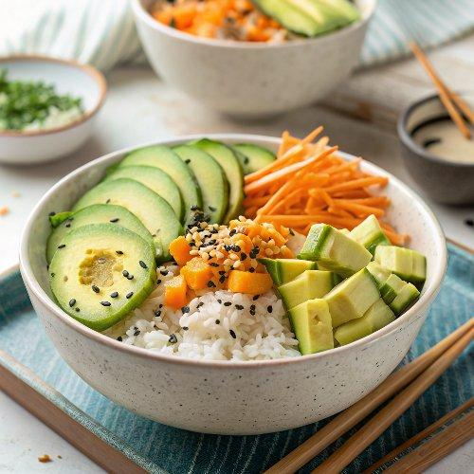

INGREDIENTS  - 1 recipe sushi rice  - 3-inch (8cm) piece of cucumber, (matchsticked)  - 1 medium carrot, (matchsticked)  - 1 avocado, (thinly sliced)  - 1 mango (thinly sliced)  - 1 cup (240ml) frozen shelled edamame (thawed)  - 6 sheets roasted seaweed snack ((or 1 nori seaweed sheet), cut into strips)  - 2 green onions, (chopped)  - 2 tsp sesame seeds  - Soy sauce & Sriracha to taste | PREP  COOK  1. Put the bowls together by putting a layer of rice in the bottom, then dividing the veggies among the bowls, displaying them as you like. Sprinkle with sesame seeds and serve with soy sauce and Sriracha.  PLATING

