EASY OVERNIGHT OATS RECIPE  COOK TIME: 8h 5m  SOURCE:  #quick #healthy #make-ahead | 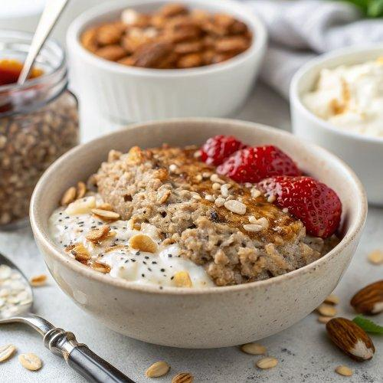

INGREDIENTS  - 1/2 cup rolled oats (old fashioned oats)  - 5 oz almond milk (just under 2/3 cup) or your milk of choice)  - 1/4 cup Greek yogurt (fat free or whole yogurt*)  - 1 Tbsp maple syrup  - 1 Tbsp chia seeds  - Blueberry Lemon: 1/4 cup blueberries + lemon zest  - Strawberry Chocolate: 1/3 cup strawberries + mini chocolate chips  - Raspberry peach: 1/3 cup peaches or nectarine + raspberries  - Banana nut: 1/2 banana + chopped pecans | PREP  COOK  1. In a mason jar, add all of your ingredients: rolled oats, almond milk, yogurt, maple syrup, and chia seeds. Stir until well combined then cover and refrigerate overnight.  2. To serve, add your favorite toppings and enjoy it out of the jar, or transfer to a bowl and sprinkle on your favorite fruit or nut toppings.  PLATING

