CHOCOLATE-COVERED STRAWBERRIES  COOK TIME: 45 min  SOURCE:  #quick #sweet #chocolate | 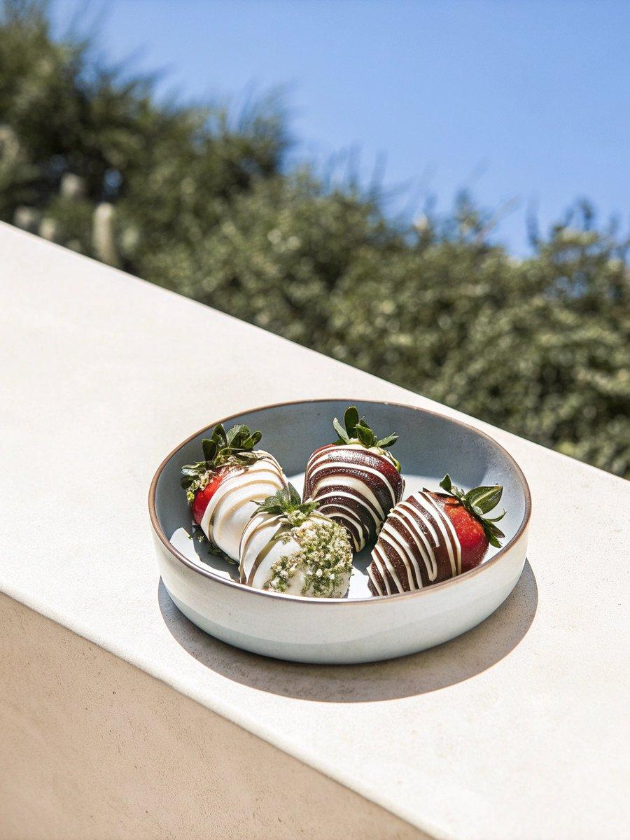

INGREDIENTS  - 1 lb (454 g) strawberries, (washed and dried thoroughly)  - 6 oz (170 g) semisweet chocolate, (chopped)  - 1 tsp (5 ml) coconut oil or vegetable shortening, (divided)  - 3 oz (85 g) white (and/or milk chocolate), for drizzling, (chopped, optional)  - Mini chocolate chips, chopped nuts, or sprinkles for coating, (optional) | PREP  COOK  1. Line a rimmed baking sheet pan with parchment paper or a silicone baking mat.  2. Place the semisweet chocolate and 3/4 teaspoon coconut oil in a small, deep microwave-safe bowl (a 2-cup measuring cup works well here). Microwave in 30-second bursts, stirring between each burst, until just melted. Be careful not to overheat.  3. Insert a toothpick into the strawberry’s stem, pushing the leaves upward, and dip into the semisweet chocolate, coating completely. Tapping the toothpick, let the excess chocolate fall back into the bowl. If desired, dip into a shallow bowl of chocolate chips, nuts, or sprinkles. Set the strawberry on the parchment, sliding forward slightly, and continue with the remaining strawberries. If the chocolate becomes too cool and firm at any point, simply reheat briefly in the microwave.  4. If a drizzle topping is desired, place the white chocolate and 1/4 teaspoon coconut oil in a microwave-safe bowl. Microwave for 30 seconds, stir, then 15-second increments, stirring between each burst, until just melted. Be careful not to overheat.  5. Remove the white chocolate to a piping bag or ziptop bag and snip a very small hole in one corner. With the toothpick still inserted, lift the strawberry up and drizzle the white chocolate over the strawberry, placing back on the parchment when finished. This will result in a cleaner, prettier drizzle. Drizzling directly on the baking sheet is doable but may result in a messier appearance. Repeat until all strawberries are decorated.  6. Let the strawberries set before serving, about 30 minutes at room temperature or 15 minutes in the fridge. Remove toothpicks before serving.  PLATING

