INSTANT SPICY KOREAN COLD NOODLES (BIBIM NAENGMYEON)  COOK TIME: 10 min  SOURCE:  #quick #spicy #noodles | 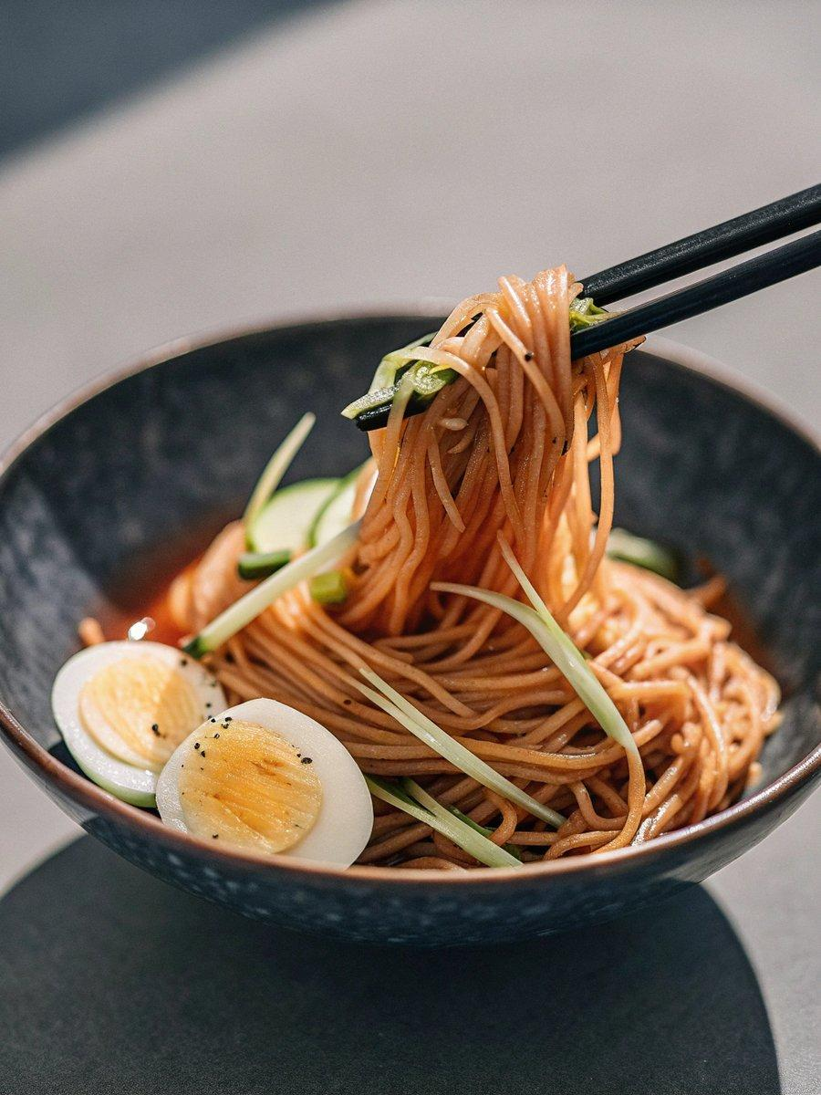

INGREDIENTS  - Instant spicy Korean cold noodles  - 1 medium cucumber (seeds removed, julienned (optional)  - 1.5 hard-boiled eggs (, cut in half (optional) | PREP  COOK  1. Take out the frozen radish pickle and pollock from the packet and defrost them on a separate plate at room temperature for about 30 mins. (This step is only necessary if they are frozen. In my case, even though I defrosted them for 30 mins, I had to separate them with my finger tips as they were still frozen. My finger tips were freezing cold! If this happens to you, just rinse your hands in warm tap water in between separating. )  2. Put some hot water into a large pot and boil it for 2 to 3 mins. (You could use cold water then it just takes longer to boil it.) Once it starts to boil, add the noodles into the pot and boil it for another 2 to 3 mins. As it boils, use a pair of tongs to shake the noodles up a bit to separate them.  3. Drain the pot and rinse the noodles in cold running water. You could add a tray of ice cubes to speed up this process – you want cold noodles. Leave the noodles in the sieve/colander until the excess water gets drained (about 30 sec to 1 min).  4. Gather one serving portion of noodles with your hand and put it into a medium sized salad bowl. Add the pickled radish, pollock and the sauce. Optionally, you could also add cucumber and/or boiled eggs. Repeat this for the rest of the servings.  5. Serve and enjoy!  PLATING

