COCONUT BANANA CREAM CHOCOLATE TRUFFLE PIE WITH DULCE DE LECHE  COOK TIME: 10 min  SOURCE:  #chocolate #sweet #comfort-food | 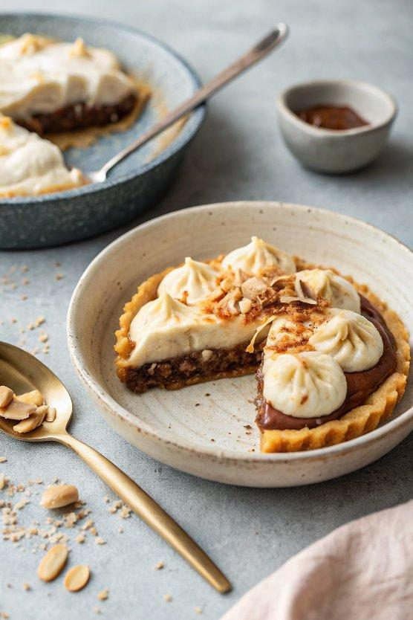

INGREDIENTS  - 1 1/2 cups graham cracker crumbs  - 6 tbsp butter (melted)  - 1 tbsp honey  - 12 oz semi sweet chocolate (chopped)  - 1 cup (240ml) heavy cream  - 1 tbsp vanilla  - 2 1/2 cups coconut milk (about 1 1/2 cans)  - 1/4 cup sugar  - 1/4 cup cornstarch  - 2 eggs  - 1/4 tsp salt  - 1 tsp vanilla  - 1/2 tsp coconut extract  - 3/4 cup shredded sweetened coconut  - 2 ripe bananas (mashed)  - 1 cup (240ml) toasted coconut  - 1/2 cup dulce de leche  - 1/4 cup chocolate chips  - 2 tbsp milk  - 2 bananas (sliced, for serving/granish) | PREP  COOK  1. Mix graham cracker crumbs, honey and melted butter until well blended . Press mixture into an 8 or 9-inch (23cm) pie plate. Use your fist to really press hard into the pan. Sometimes I like to use the back of a 1/4 c measuring cup and really push into the crust. This will help the crust stay together when cutting. Place in the fridge.  2. To make the truffle filling, in a heat proof bowl add the semi sweet chocolate and heavy cream. Microwave on 30 second intervals, stirring each time until the chocolate is melted and the cream is smoothly mixed with the chocolate. This took me a total of 2 minutes. Once the chocolate is melted and smooth, stir in the vanilla.  3. Remove the pie crust from the fridge and pour the truffle filling into the pie. Smooth out the filling, cover and place in the freezer for 30 minutes.  4. While the truffle filling cools make the coconut banana cream filling. In a medium sauce pot combine the coconut milk and cornstarch. Whisk until the cornstarch is completely dissolved and there are no lumps. Add the sugar, eggs and salt, whisk until smooth. Place the pot on the stove and bring to a boil, stirring constantly. Simmer until the cream thickens, about 5 minutes. Remove from the heat and stir in the vanilla, coconut extract and coconut. Stir in the mashed bananas.  5. Remove the pie from the freezer and spread the coconut banana cream filling over the truffle pie. Place in the fridge for at least 2 hours or if you have to, the freezer for one hour.  6. Before you are ready to serve, microwave the chocolate and milk together until melted and smooth.  7. Spread the toasted coconut over the top of the pie and sprinkle with fresh sliced bananas. Drizzle with the melted chocolate and dulce de leche. Dig in!  PLATING

