CHOCOLATE OATMEAL BARS RECIPE  COOK TIME: 25 min  SOURCE:  #healthy #quick #no-bake | 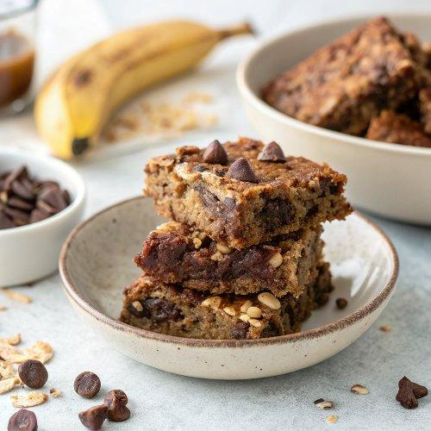

INGREDIENTS  - 1 2/3 cups oat flour (gluten-free if needed) )  - 1 cup (240ml) oats (gluten-free if needed) )  - 1 cup (240ml) almond flour (see notes)  - 2 medium bananas (peeled)  - 3 Tbsp maple syrup (or any other liquid sweetener)  - 2 medium bananas (peeled)  - 200 g dates (soaked)  - 1/4 cup peanut butter (or any other nut/seed butter of choice)  - 1/2 cup cocoa powder  - 1 Pinch of salt  - 1 tsp vanilla extract | PREP  COOK  1. You can watch the video in the post for visual instructions.  2. First, preheat the oven to 355 °F/180°C (355°F) and line a 7x7-inch (18x18cm) square baking dish (18 cm) or 9x6-inch (23x15cm) baking pan with parchment paper.You could use an 8x8 pan, but the bars will be thinner. For a much larger pan, it's best to double the recipe.  3. Then, process all the dough ingredients in a food processor until dough-like.  4. Press ¾ of the dough into the prepared pan, using the bottom of a flat glass to help make a single even layer.  5. Then, rinse the food processor and process the chocolate layer ingredients until smooth and creamy.  6. Pour the chocolate layer over the oat base, and then crumble and sprinkle the remaining oat mixture over the top.  7. Crumble the remaining 1/4 dough on top of the chocolate layer.  8. Bake for 25-30 minutes, until golden brown on top, then leave the banana breakfast bars to cool completely (they will firm up/set as they cool). Finally, cut them into bars, and enjoy!  9. You can optionally drizzle the chocolate oat bars with a simple homemade icing (regular or sugar-free), homemade vegan Nutella, or another nut/seed butter.  PLATING

