EDAMAME SALAD WITH PEANUT SAUCE  COOK TIME: 20 min  SOURCE:  #healthy #quick #refreshing | 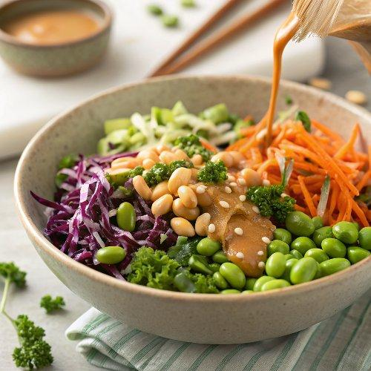

INGREDIENTS  - 16 oz frozen shelled edamame  - 1 cup (240ml) shredded red cabbage  - 1 cup (240ml) shredded carrots  - 1/2 cup chopped green onions  - 2 cups (480ml) chopped kale  - 1/4 cup chopped cilantro (optional)  - 1/2 cup chopped peanuts (or cashews)  - 6 tbsp creamy peanut butter  - 3 tbsp seasoned rice vinegar  - 3 tbsp low sodium soy sauce  - 3 tbsp pure maple syrup  - 1 tsp toasted sesame oil  - 1/4 tsp ground ginger  - 1 tsp Sriracha hot sauce (or to taste) | PREP  COOK  1. Cook or thaw the edamame according to package instructions. Rinse under cold water.  2. Add the edamame to a large bowl, along with all other salad ingredients.  3. In a small-medium bowl, add the peanut sauce ingredients and whisk until smooth. Whisk in a little warm water if it's too thick.  4. Pour the sauce over the salad and toss until well combined.  5. Sprinkle more chopped nuts on top, if desired. Cover and chill in the refrigerator for at least an hour before serving, if possible.  PLATING

