GINGER CHICKEN  COOK TIME: 20 min  SOURCE:  #comfort-food #quick #stir-fry | 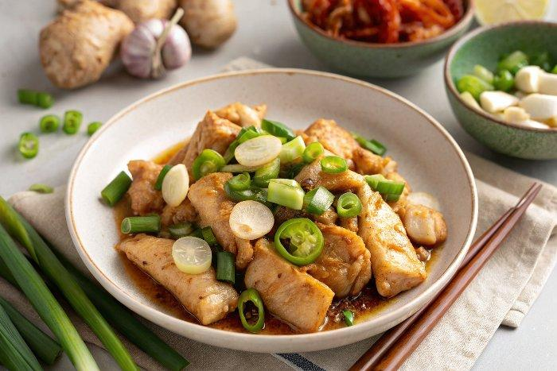

INGREDIENTS  - 3 scallions (cut into 2-inch long pieces, with the white and green parts separated)  - 4 cloves garlic (cut in half)  - 6 slices ginger (1/4 inch thick)  - 1 tbsp vegetable oil (can substitute canola oil or avocado oil)  - 24 oz boneless skinless chicken thighs (680 g, cut into 1-inch chunks)  - 3 shallots (cut into quarters)  - 1/4 cup Shaoxing wine  - 1 1/2 cups low sodium chicken stock  - 1 tsp light brown sugar  - 2 tbsp soy sauce  - 1 tsp dark soy sauce  - 1/4 tsp white pepper  - 2 tsp oyster sauce (optional)  - 1 tbsp cornstarch (mixed with 1 tbsp water) | PREP  COOK  1. Using a cleaver, lightly smash the white parts of the scallions, the garlic, and the ginger (use a firmer hand on the ginger). This releases the flavors of the aromatics for a more flavorful dish.  2. Spread the canola oil around the perimeter of the wok, and heat it until it just starts smoking. Add the smashed ginger slices, and fry for 15 seconds.  3. Spread the chicken pieces in a single layer in the wok. Sear for 45 seconds. Flip them and fry the other side for another 30 seconds.  4. Add in the white parts of the scallions, garlic, and shallots. Continue to stir-fry over high heat, mixing everything together for another 30 seconds.  5. Add the Shaoxing wine, and stir-fry again for 20 seconds. Next, add in the chicken stock, brown sugar, soy sauce, dark soy sauce, white pepper, and oyster sauce (optional, but it’ll give the dish a nice additional flavor!). Cover and continue to cook on high heat for 5 minutes.  6. Remove the cover, and cook for another 7 minutes to reduce the liquid. Mix in the green parts of the scallions, and then immediately stir in the cornstarch and water mixture to thicken the sauce. Add more cornstarch slurry if you like a thicker sauce.  PLATING

