BRILLIANT BOLOGNESE  COOK TIME: 55 min  SOURCE:  #comfort-food #pasta #hearty | 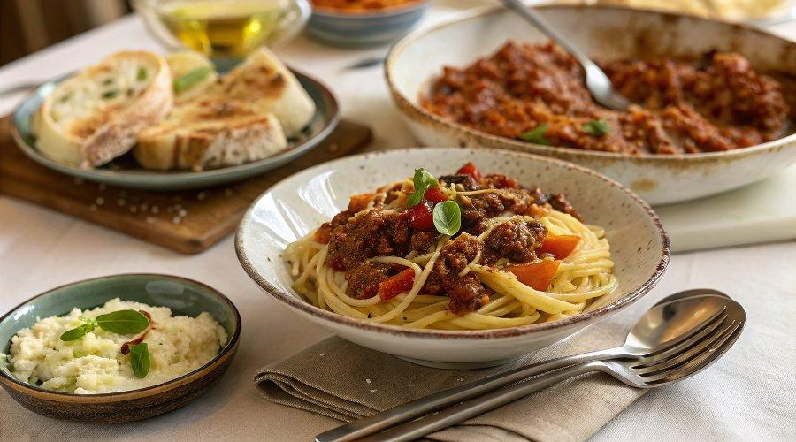

INGREDIENTS  - olive oil  - 500 g higher-welfare minced beef  - 50 g higher-welfare smoked pancetta  - 1 x 180 g jar of Jamie’s Brilliant Bolognese Paste  - 1 x 400 g tin of quality plum tomatoes  - 300 g dried spaghetti  - optional: Parmesan cheese, to serve | PREP  COOK  1. Place a casserole pan on a medium heat with 1 tablespoon of olive oil. Add the mince, roughly chop and add the pancetta and fry for 10 minutes, or until golden, stirring regularly.  2. Stir in the Bolognese paste and fry for 1 minute, then tip in the tomatoes, breaking them up with the back of a spoon, along with 300ml (1.2 cups) of water.  3. Bring to the boil, then cover and cook gently for 45 minutes (or bake in a preheated oven at 180°C/350°F/gas 4 for 1 hour), or until the sauce is thickened, adding a splash of water if needed. Season to perfection with sea salt and black pepper.  4. When there’s 10 minutes to go, cook the pasta in a large pan of boiling salted water according to the packet instructions, then drain. Toss with the sauce, then divide between bowls and grate over some Parmesan, if you like. Delicious with a crisp green salad.  PLATING

