HAPPY FISH PIE  COOK TIME: 1h 5m  SOURCE:  #comfort-food #hearty #family-friendly | 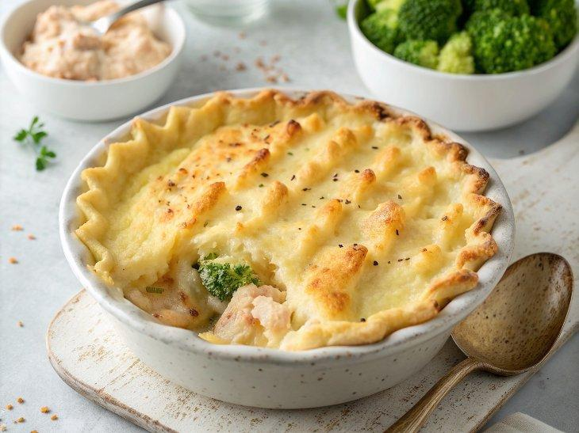

INGREDIENTS  - 1 kg potatoes  - 1 large head of broccoli (480 g)  - optional: 3 large free-range eggs  - 3 leeks (480 g)  - olive oil  - 2 heaped tbsp plain flour  - 2 tsp of your favourite mustard  - 600ml (2.5 cups) semi-skimmed milk  - 800 g mixed frozen fish chunks, from sustainable sources  - 75 g Cheddar cheese  - 1 bunch of chives (20 g)  - 1 lemon | PREP  COOK  1. Preheat the oven to 180°C/350°F (175°C)/gas  4. Peel the potatoes, halving any larger ones, then cook in a pan of boiling salted water for 20 minutes, or until tender. Trim, finely chop and reserve the broccoli stalk. Chop the head into florets and add to the pan with the eggs, if using, for the last 7 minutes. Cool the eggs under cold running water. Drain the potatoes and broccoli, and steam dry.  2. Meanwhile, trim the leeks, halve lengthways, then wash and finely slice. Place in a large shallow casserole pan on a medium heat with 1 tablespoon of olive oil and the chopped broccoli stalk. Cook for 10 minutes, or until soft, stirring regularly. Stir in the flour and mustard, then gradually stir in the milk. Simmer for 5 minutes, stirring occasionally, then season to perfection.  3. Add the fish chunks and simmer for another 5 minutes, then grate in most of the cheese. Finely chop the chives and fold in most of them. Peel, halve and dot in the eggs, if using, and finely grate over the lemon zest.  4. Mash the potato and broccoli – rustic or smooth, the choice is yours. Season to perfection, then spoon over the dish, fork up the top for added texture, grate over the last bit of cheese and spritz with oil. Bake for 35 minutes, or until golden and bubbling. Rest for 5 minutes, sprinkle over the remaining chives, and serve with lemon wedges.  PLATING

