PRAWN CURRY  COOK TIME: 25 min  SOURCE:  #comfort-food #spicy #seafood | 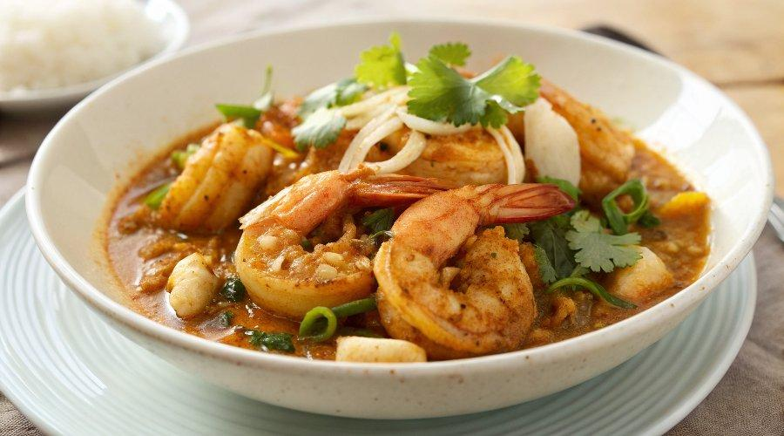

INGREDIENTS  - 6 tbsp oil (vegetable, sunflower or peanut)  - 3 medium onions, chopped  - 10 garlic cloves, peeled  - 1/2 thumb-sized piece of ginger, peeled  - 1/2 bunch of coriander stalks, finely chopped, plus some leaves to garnish  - 2 tsp paprika  - 1 tsp turmeric powder  - 2 tsp medium chilli powder  - 50 g creamed coconut (use the solid block type, or 50 ml coconut milk would work too)  - 2–3 tbsp fish sauce  - 600 g large, raw king prawns, peeled and deveined | PREP  COOK  1. Heat the oil in a large casserole dish or wok set over a medium-high heat. Add the chopped onions and cook slowly, turning down the heat to low-medium, and stirring every 4–5 minutes until softened and starting to colour lightly and become oily – this will take at least 15 minutes (see cooking onions, page 102 of The Rangoon Sisters for more information).  2. While the onions are cooking, crush the garlic cloves and ginger to a paste using a pestle and mortar, or blitz in a food processor.  3. Once the onions are ready, add the crushed garlic, ginger and coriander stalks and fry for a few minutes until fragrant. Add the spices and creamed coconut, breaking it up into smaller pieces as you stir. It should melt in. Finally, add the fish sauce and the prawns and cook over a medium heat for about 5 minutes or until the prawns are cooked through.  4. Serve hot on steamed rice and garnish with coriander leaves.  PLATING

