AIR FRYER BROCCOLI  COOK TIME: 10 min  SOURCE:  #quick #healthy #air-fried | 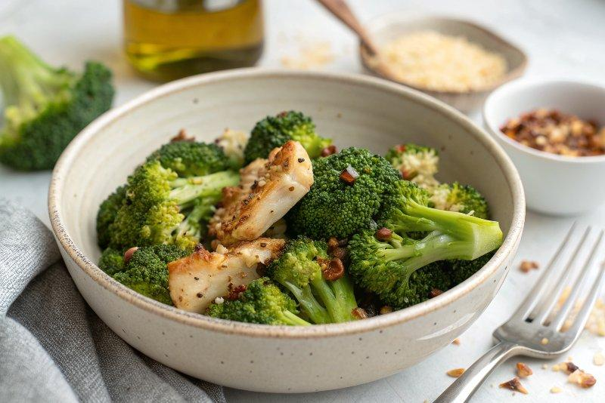

INGREDIENTS  - 1 stalk or 450 g broccoli broken into florets, stalk roughly chopped  - 1 tbsp olive oil  - 1/2 tsp garlic granules  - 1/2 tsp smoked paprika | PREP  COOK  1. Put the broccoli in a bowl, drizzle with olive oil, spices and sprinkle with plenty of salt and pepper. Mix with your hands well to coat, then put into the basket of an air-fryer, making sure they’re in one layer.  2. Heat to 180c and air-fry for 8-10 mins, shaking halfway.  PLATING

