MOM'S POPPY SEED ROLL (ROULETTE) RECIPE  COOK TIME: 30 min  SOURCE:  #comfort-food #baking #traditional | 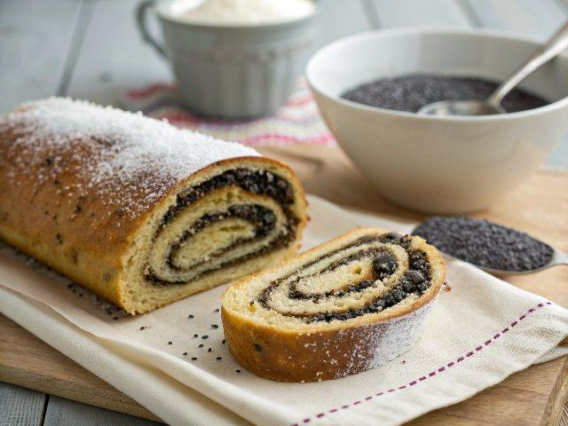

INGREDIENTS  - 1 and 1/3 cups 1% milk  - 1 Tbsp active dry yeast (I used Red Star Brand)  - 2 large eggs  - 3/4 cup sugar  - 1 stick (8 tbsp salted butter (or unsalted butter plus 1/4 tsp salt)  - 4 cups (960ml) bleached all-purpose flour (I used flour Made in Canada, which is best for this recipe)  - 1/2 tsp vanilla extract or vanilla powder  - 1 cup (240ml) poppy seeds (you will need a food grinder to prepare these)  - 1 egg white (for egg wash)  - 8 oz sweetened condensed milk (from a 14 oz can)  - 1 cup (240ml) raisins | PREP  COOK  1. How to make Russian Poppy Seed Rolls (Roulette):  2. Heat 1 1/3 cups milk in the microwave until it's luke-warm. Pour milk in a large mixing bowl (preferably the bowl from your KitchenAid mixer). Add 1 tbsp yeast, 2 Tbsp sugar and 1 cup (240ml) flour. Mix until flour is well blended. Let stand in a warm oven (100 degrees) for 1/2 hour or put it on the counter for 1 hour at room temperature if you have all the time in the world. Dough should rise about 1.5 times in volume. Stir dough lightly.  3. Melt 1 stick (8 Tbsp) butter (until it's just melted - it should not be hot). Add butter to the batter. Add 2 whole eggs. Add the rest of your 3/4 cup of sugar, 1/2 tsp vanilla and 1 cups (240ml) flour. Whisk together.  4. Using the dough hook (on speed 2), add the remaining 2 cups (480ml) of the flour 1/2 cup at a time. After all the flour is in, let it continue mixing 15 minutes. Dough is ready when it is no longer sticking to the sides of the bowl. Finished dough will be soft. It will feel sticky to the touch but should not stick to your fingers.  5. Place dough in a very large mixing bowl (our Kitchenaid bowl is 6 Qts so I left it in the same bowl), cover with plastic wrap and set in a warm place (in a 100 degree oven or in the sun) Let sit 2.5 hours to rise (until about 3-4 times in volume) Carefully peel off cellophane when it's done.  6. Prepping the Poppy Seeds while dough is rising:  7. Fill medium saucepan with 1 cup (240ml) poppy seeds and add enough water for impurities to float to the top, drain off the water and repeat.  8. Add 3 cups (720ml) water to the pot. Over medium heat, bring to a simmer. (Don't boil). Turn off. Cover with lid and let it sit for 30 minutes.  9. Return to a simmer (don't boil). Turn off. Cover and let it sit for another 30 minutes. Drain poppy seeds by keeping lid on and put cheese cloth on lid to catch stray poppy seeds, or if you have a fine mesh sieve, use it!  1  0. Push the poppy seeds through a food grinder using the fine grinding plate. You can also use a coffee grinder and do it in smaller batches. With the meat grinder, you need to push firmly. The seeds won't grind well unless they are under pressure. P.S. I've tried putting them through a food processor and it did not work.  1  1. Mix 8 ounces of sweetened condensed milk into ground poppy seeds.  1  2. Assembling Poppy Seed Rolls (Rouletti):  1  3. Line an extra large cookie sheet with parchment paper.  1  4. Put dough onto a clean, dry, non-stick surface (a sheet of parchment paper works well). Divide into 4 equal pieces.  1  5. Roll out the dough into an 11" x 8" oval-ish shape; similar to a thin crust pizza dough. It should not stick to your rolling pin. Spread 1/2 cup poppy seed mixture over the dough and sprinkle about 30-40 raisins over the poppy mixture.  1  6. Roll the Roulette (not too tight!) and Place side-by-side on the lined baking sheet. Brush the top with egg wash (1 egg white, 1/2 tsp sour cream, 1/2 tsp sugar - whisked together). Let them rise on the counter for 1 hour (or in a 100˚F oven for 30 minutes).  1  7. Preheat Oven to 360°F (180°C) and bake 28-30 min until the tops are deep golden (but not brown).  PLATING

