CALZONE  COOK TIME: 13 min  SOURCE:  #comfort-food #baked #cheesy | 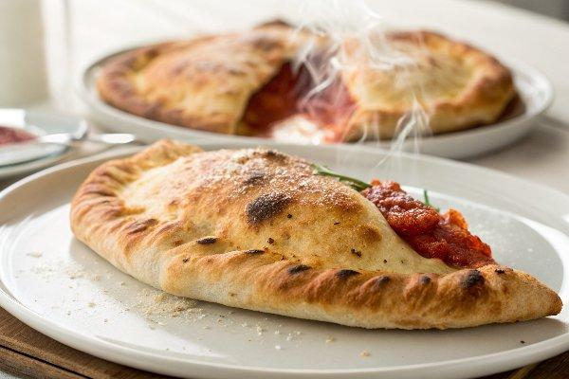

INGREDIENTS  - 1 pizza dough (1 lb/450 g ball)  - 1/2 cup pizza sauce (120 ml)  - 1 cup (240ml) ricotta cheese (230 g)  - 1/3 cup pepperoni slices (44 g)  - 1 cup (240ml) shredded mozzarella (113 g)  - 1 large egg  - 1 tbsp olive oil  - 2 tbsp grated Parmesan cheese | PREP  COOK  1. Preheat the oven to 475°F (245°C) with the oven rack in the lower third of the oven. Line a large baking sheet with parchment paper.  2. On a lightly floured surface, divide the pizza dough into 4 equal pieces. Roll each piece into a 7-inch (18cm) circle (about ¼-inch thick).  3. Working with 1 dough round at a time, spread about 2 tablespoons of the pizza sauce on one half of the circle. Top with 2 tablespoons of ricotta cheese, about 6 pepperoni slices, and sprinkle with ¼ cup of mozzarella. Fold the empty side of the dough over the fillings and crimp edges to seal. Place the calzone on the baking sheet. Repeat the process with the remaining pizza dough, sauce, ricotta, pepperoni, and mozzarella, placing each calzone with some space between them on the pan.  4. In a small bowl, whisk together the egg and 1 teaspoon of water. Brush the calzones lightly with egg wash. Cut 3 (about 1/2-inch long) slits in the top of each calzone to allow steam to escape.  5. Bake for 13 to 16 minutes or until the crust is golden brown. Immediately brush the hot calzones with olive oil and sprinkle with parmesan. Serve with additional pizza sauce.  PLATING

