VEGAN BUFFALO CHICKPEA QUEASADILLAS  COOK TIME: 40 min  SOURCE:  #quick #comfort-food #grilled | 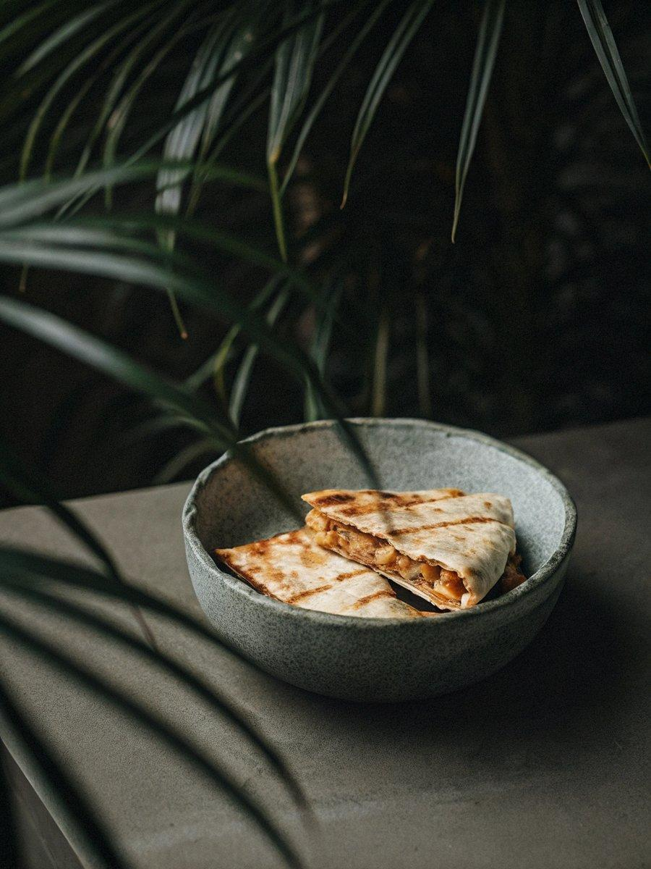

INGREDIENTS  - 1 cup (130-140 g) raw cashews, (soaked overnight (or soaked in boiling water for 1 hour)  - 1/2 cup (115 g) vegan unsweetened plain yogurt (see Note 1)  - 2 tbsp water or vegetable broth  - 1/2 cup (115-130 g) salsa of choice (see Note 2)  - 1 tsp ground cumin  - 1/2 tsp chili powder  - 1/2 tsp smoked paprika  - 1 tsp kosher salt  - 2 tbsp nutritional yeast  - 1/4 cup (56 g) vegan butter (1/2 stick) )  - 4 tbsp Frank’s hot sauce, (original cayenne or Xtra hot, or hot sauce of choice (see Note 3) )  - 1/8 tsp garlic powder  - A pinch of cayenne pepper (optional; I don’t use it when I use Xtra hot sauce)  - A pinch of kosher salt  - 2 tsp coconut sugar or brown sugar  - 2 tsp olive oil  - 1 medium yellow onion, (diced)  - 4 cloves garlic, (minced)  - 1 (15-oz /425 g) can chickpeas, drained and rinsed (see Note 4)  - 1 small bunch of scallions (4-5 scallions), (white and light green parts only, sliced thinly)  - 8 large flour tortillas**** | PREP  COOK  1. Prepare the Mexican Cheese Sauce. Drain the soaked cashews and pat dry. Add the cashews, along with the remaining sauce ingredients, to a high-powered blender. Blend until thick, creamy, and smooth. The sauce should be quite thick and creamy, but if you’d like it to be even thicker, add the sauce to a saucepan over medium-low heat for a few minutes to thicken up slightly.  2. Next, make the buffalo sauce. Melt the vegan butter in a heatproof bowl in the microwave (or in a saucepan on the stove). To the melted butter, add the hot sauce, garlic powder, cayenne pepper (if using), salt, and sugar. Whisk until the hot sauce and butter are completely incorporated.  3. Pour the drained and rinsed chickpeas in a medium bowl and roughly mash them with a fork or a potato masher, leaving some beans intact.  4. Heat the 2 teaspoons oil in a large skillet over medium heat and once the oil is shimmering, add the diced onion. Cook for 4 to 5 minutes or until softened and they have a little color, then add the garlic and cook for an additional 1 minute.  5. To the onions, add the buffalo-butter sauce and the mashed chickpeas, and bring the mixture to a boil. Reduce the heat to low and simmer for 2 minutes, stirring occasionally. Add the scallions and stir to combine. Turn off the heat and wipe out the skillet so you can reuse it for making the quesadillas.  6. Assemble the quesadillas. Spread an even layer of the Mexican Cheese Sauce (1/4-1/3 cup) onto one of the eight tortillas. Arrange about 1/2 cup of the Buffalo Chickpea Filling on top. Place another tortilla on top to cover.  7. Lightly grease the large skillet with a bit of oil and place over medium heat. Once hot, add the prepared quesadilla to the skillet. Place a slightly smaller skillet on top of the quesadilla so that it presses down on the quesadilla, resulting in a nice crispy exterior. I also like to weigh the smaller skillet down with a couple cans of beans/tomatoes or just press down on the skillet with my hands (using a kitchen towel so I don't burn myself). Cook the quesadillas for 3 minutes, then flip and cook another 2 to 3 minutes, or until both sides are crispy and nicely browned. Repeat with the remaining sauce, filling, and tortillas.  PLATING

