ULTIMATE BARBECUE BURGERS  COOK TIME: 40 min  SOURCE:  #grilled #comfort-food #bbq | 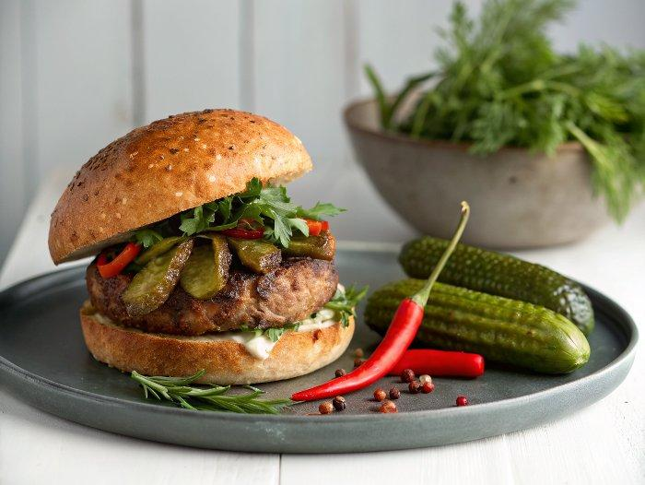

INGREDIENTS  - 1 x 840 g jar large whole pickled gherkins  - 1 fresh red chilli  - 1/2 a bunch of fresh herbs (10 g), such as parsley, dill, mint  - 3 or 4 whole cloves  - 800 g higher-welfare minced chuck steak (22% fat)  - 8 slices of higher-welfare smoked pancetta or bacon  - 2 tsp American or English mustard  - 4 thin slices of Gruyère cheese  - 2 ice cubes  - 4 sesame-topped brioche burger buns  - 3 heaped tbsp Greek yoghurt  - 1 heaped tbsp tomato ketchup  - 1 tsp Worcestershire sauce  - 1 tsp Tabasco sauce  - 1 tsp English mustard  - 1/2 a lemon  - 1/4 of an iceberg lettuce  - 400 g fresh mixed-colour beetroots  - 1 eating apple  - 1/2 a bunch of fresh mint (15 g)  - 1/2 a lemon  - extra virgin olive oil  - Weber barbecue tongs  - Weber barbecue spatula  - Weber burger press  - Weber basting dome x 2 | PREP  COOK  1. Preheat the griddle with the burners on medium. The temperature gauge should register about 200°C (400°F).  2. Remove the gherkins from the jar and set to one side. Trim and finely slice the chilli, roughly chop the herbs and place in the gherkin jar with the cloves. Finely slice the gherkins on the diagonal (use a crinkle-cut knife, if you’ve got one), then return them to the jar, pop the lid on and give it a few turns to get the flavours all mixed up.  3. Place most of the burger sauce ingredients in a bowl, then squeeze in the lemon juice, mix and season to perfection. Finely slice the lettuce, add to the bowl and give it a good mix.  4. For the rainbow slaw, wash, trim and grate the beetroot and apple, roughly chop the mint and any nice beetroot leaves, and place in a bowl. Squeeze over the lemon juice, drizzle over 1 tablespoon of extra virgin olive oil and season to perfection.  5. Scrunch up the mince with your hands and give it a good knead, then divide into 4 and shape into cricket balls, patting them together well but not packing them too tightly. Season with sea salt and black pepper.  6. Place the burgers on the griddle, squash to about 1½cm thick using a burger press or spatula, and add the bacon alongside. Cook for 1 minute, then flip the burgers and bacon, brushing ½ teaspoon of mustard over the cooked side of each burger. Cook for a further 1 minute, flip the burgers again and top each with a slice of cheese and 2 slices of crispy bacon.  7. Place the basting domes on the griddle so they are each covering 2 burgers, then slide 1 ice cube under each – they will melt, creating steam and giving you beautiful oozy cheese. Cook for 1 more minute, or until the cheese has melted.  8. Cut the buns in half and toast on the griddle for 1 minute, turning halfway.  9. To serve, spread some burger sauce over the base of each bun, then top with a cheesy burger, a dollop of slaw and a few gherkin slices – the rest will keep happily in the fridge for up to 1 week. Dig in!  PLATING

