CHANA AUR ALOO KI SOOKHI SABZI RECIPE  COOK TIME: 20 min  SOURCE:  #quick #comfort-food #healthy | 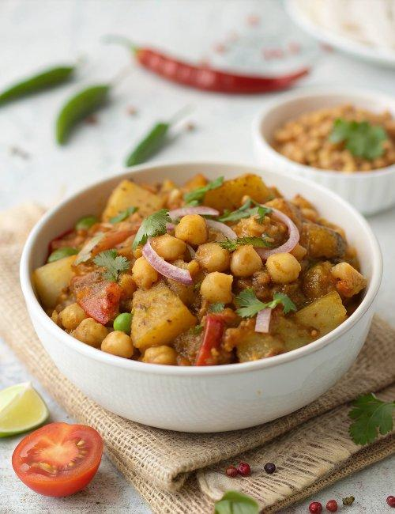

INGREDIENTS  - 1 cup (240ml) Kabuli Chana (White Chickpeas) boiled  - 3 Potatoes (Aloo) boiled  - 1 Onion finely chopped  - 1 Tomato finely chopped  - 1 Green Chilli finely chopped  - 1 tbsp Ginger Garlic Paste  - 1 tsp Red Chilli powder  - 1/2 tsp Turmeric powder (Haldi)  - 2 tsp Coriander Powder (Dhania)  - 1 tsp Garam masala powder  - 1 tsp Amchur (Dry Mango Powder)  - 1 tsp Cumin seeds (Jeera)  - 4 sprig Coriander (Dhania) Leaves finely chopped for garnish  - 1-inch (3cm) Ginger cut in juliennes (long thin strips) for garnish  - 1 tbsp Oil  - Salt for taste | PREP  COOK  1. To begin making Chana Aur Aloo Ki Sookhi Sabzi, soak the chickpea or chana over night and pressure cook the soaked chana in enough water for 3 whistles and keep aside.  2. Similarly, wash and boil the potatoes with 1 cup (240ml) water in a pressure cooker for 2 whistles; peal the skin, cut into cubes and keep aside.  3. Heat oil in a pan on medium heat, add the cumin seeds and let it splutter.  4. Add the finely chopped onions and saute until it turns transparent.  5. Add the ginger and garlic paste and cook until the raw smell goes away.  6. Add the chopped tomatoes and green chilli and saute until the tomatoes are soft and well cooked.  7. Now add the red chilli, turmeric, coriander and garam masala powder and sauce until the spices are cooked.  8. Add the cooked chickpeas and the boiled potato cubes, season with salt and mix well.  9. Let this mix cook for another 10 minutes.  1  0. Add the amchoor powder, give it a good mix and switch off the flame.  1  1. Garnish with coriander leaves and ginger juliennes and serve the Chana Aur Aloo Ki Sookhi Subzi Recipe along with phulkas or parathas for your kids lunch box or for the weeknight dinner.  PLATING

