TWIX BARS  COOK TIME: 15 min  SOURCE:  #sweet #no-bake #healthy | 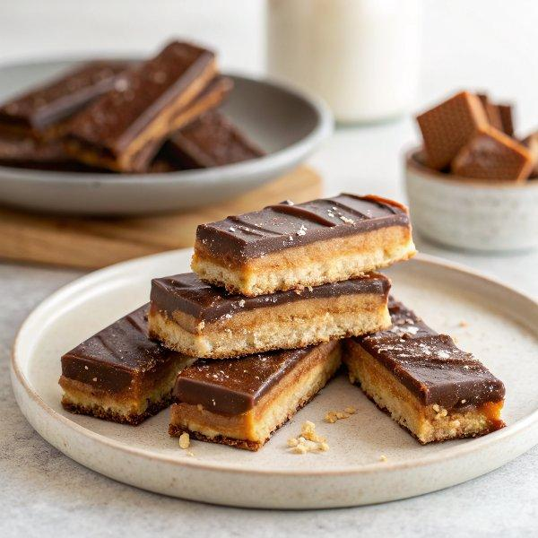

INGREDIENTS  - 1 cup (240ml) almond meal or almond flour  - 1/8 tsp sea salt  - 1/8 tsp baking soda  - 2 tbsp maple syrup  - 1 1/2 tbsp melted coconut oil  - 1 1/2 tsp vanilla extract  - 1 cup (240ml) dates (pitted and soaked in hot water for 10 - 20 min, then drained)  - 2 tsp coconut oil  - 3 tbsp unsalted almond butter  - 1/8 tsp salt  - 1 tsp vanilla extract  - 1-2 cups (480ml) chocolate chips of choice (I used dark chocolate )  - 1/2-1 tbsp coconut oil | PREP  COOK  1. Cookie Layer:  2. Combine all ingredients in a bowl, using your hands to press it together until it is well mixed and a ball shape. Let sit in fridge for 10 minutes. If you'd like to do the easier option, simply press dough into bottom of a parchment lined 8x8" pan  3. Bake  4. To make traditional Twix shapes, roll dough into snakes and press snakes flat on a parchment lined baking sheet. Place shaped dough in freezer for 15 minutes before baking at 325°F (160°C) degrees for 15 minutes. Remove from oven and let sit for at least 10 minutes (ideally, until they cool completely) before removing from pan.  5. Caramel Layer:  6. Process  7. Using a food processor or blender, process all ingredients together until completely smooth. If you're using a blender, it helps to start on a "low" setting until everything is more liquidy, then switching to "high" to get rid of any chunks.  8. Assembly:  9. Spread a generous layer of the caramel on top of cookie layer; place caramel-topped cookies in freezer while you melt the chocolate in a double boiler or the microwave. (I did 1 cup chocolate chips + 1/2 Tablespoon coconut oil).  1  0. Spoon chocolate over bars, making sure to swipe it around the sides, or simply spread an even layer atop the caramel and cookie layer if using 8x8" pan. Let cool completely and enjoy!  1  1. Store in an airtight container or bag in the refrigerator for up to 1 week or in the freezer for 1-2 months.  PLATING

