CRAB AND AVOCADO PHYLLO BITES  COOK TIME: 10 min  SOURCE:  #seafood #quick #party-food | 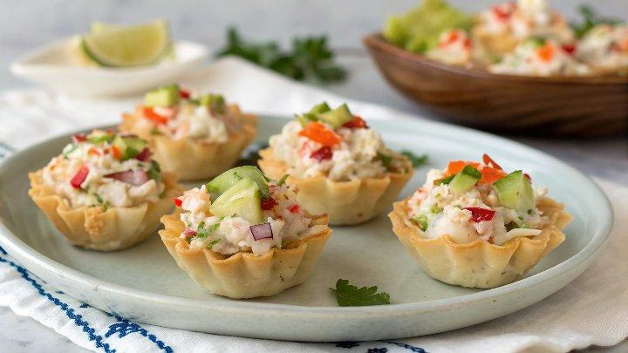

INGREDIENTS  - 1/2 tsp canola oil  - 1/4 cup minced red bell pepper  - 1/4 cup minced onions  - 1 clove garlic (minced)  - 6 1/2 oz lump crab meat  - 1/4 tsp kosher salt  - 1/8 tsp black pepper  - 15 mini phyllo shells  - 1/2 medium (2 oz haas avocado, diced small) | PREP  COOK  1. Preheat the oven to 350°F (175°C).  2. Heat the oil in a saute pan over medium heat.  3. Saute the onion, bell pepper, and garlic until soft.  4. Add the crab meat, salt, and pepper, and cook until the crab has been heated through, about 30 to 60 seconds.  5. Add about 1 heaping tablespoon of the crab filling to each phyllo shell.  6. Arrange the stuffed shells on a baking tray, and bake for 10 minutes.  7. Top each stuffed shell with avocado, and serve immediately.  PLATING

