LEMON AND GINGER ICE POPS  COOK TIME: 3h 20m  SOURCE:  #refreshing #summer #frozen | 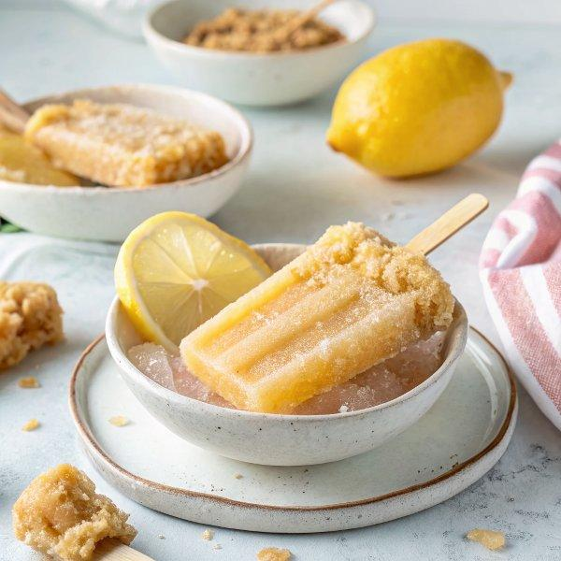

INGREDIENTS  - 2 3/4-inch (10cm) 1 oz piece fresh ginger, peeled and finely chopped  - 3 1/2 cups water  - 3/4 cup sugar  - 5 tbsp lemon juice (from 3 lemons)  - zest of three lemons  - 10 ultra thin half slices lemon (optional) | PREP  COOK  1. Put the ginger, water, sugar and lemon zest in a small saucepan and bring to a simmer.  2. Simmer until the sugar is dissolved, then remove the pan from heat and let it get to room temperature.  3. Pour the mixture through a fine strainer pressing down hard on the ginger with the back of a spoon. Mix in the lemon juice.  4. Pour the mixture into your ice pop molds, leaving 1/4-inch (10cm) at the top to let the mixture expand while it freezes.  5. Place a slice of lemon in each mold if using then insert the sticks and freeze.  PLATING

