CREAMY SALMON PICCATA  COOK TIME: 40 min  SOURCE:  #quick #comfort-food #seafood | 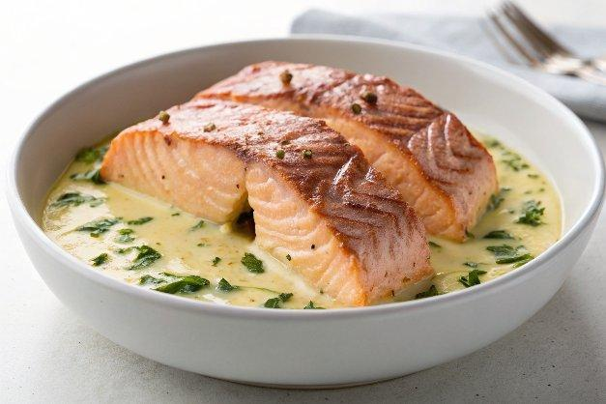

INGREDIENTS  - 4 skinless salmon fillets  - 1 pinch salt (to taste)  - 1 pinch pepper (to taste)  - 1/4 cup flour (optional)  - 2 tbsp unsalted butter  - 1 tbsp olive oil  - 4 cloves garlic (medium, minced)  - 1/3 cup dry white wine  - 1 cup (240ml) low-sodium chicken stock (broth, fat free if you can find it)  - 1-2 tsp cornstarch (leveled, or corn flour)  - 3-4 tbsp lemon juice (freshly squeezed, adjust to your tastes)  - 4 tbsp capers (rinsed and drained)  - 1/2 cup reduced fat cream (or heavy cream)  - 2-4 tbsp parsley (coarsely chopped to serve)  - 4 Lemon slices (to serve) | PREP  COOK  1. Season both sides of salmon fillets evenly with salt and pepper. Add ¼ cup of the flour to a shallow dish; dredge the salmon in the flour to evenly coat. Shake off excess.  2. Melt 1 tablespoon of butter in a large nonstick pan or skillet over medium-high heat. Add 1 tablespoon oil and swirl to mix through the butter. Add salmon; sauté 4 minutes on each side or until just cooked to your liking. Transfer salmon to a warm plate; tent with foil and set aside.  3. Add remaining 1 tablespoon butter (or oil) to pan and melt. Add the garlic; sauté for a further minute until fragrant. Add wine; bring to a boil scraping any browned bits off of the bottom of the pan. Cook until liquid almost evaporates, stirring occasionally. Add ¾ cup stock/broth to the pan along with the lemon juice; bring to a boil and cook for a further minute.  4. Mix 1 teaspoon of cornstarch (or cornflour) with 2 tablespoons of the reserved broth, whisking well to combine. Pour the mixture into the pan, stirring through the liquid to create a sauce. Cook for 1 minute or until slightly thickened. If it's not thick enough, mix the remaining cornstarch with the remaining broth and add to the centre of the pan. Stir in the cream and remove from heat and add the capers.  5. Place the salmon fillets back into the pan. Sprinkle with chopped parsley, pepper and add in lemon slices.  6. Serve immediately with the sauce over rice or pasta, vegetables of choice or with a salad.  PLATING

