ORANGE CREAMSICLE MIMOSAS  COOK TIME: 5 min  SOURCE:  #refreshing #brunch #cocktail | 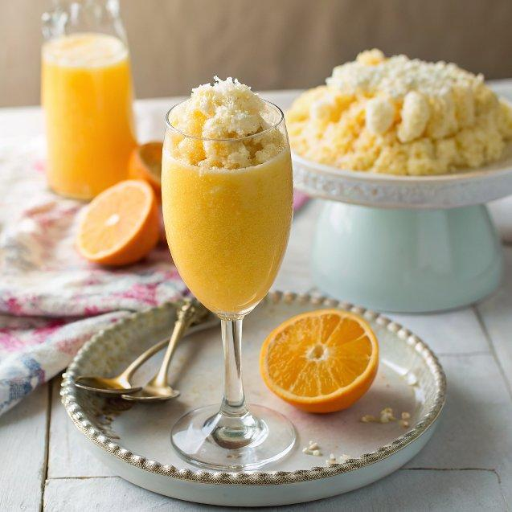

INGREDIENTS  - 2 cups (480ml) natural orange juice  - 2 tbsp half and half (or thickened cream)  - 25.4 oz Prosecco (or Champagne or any sparkling white wine)  - 2 oz Triple Sec (Cointreau or another orange liqueur) | PREP  COOK  1. Chill champagne glasses in a refrigerator.  2. Mix together the orange juice, half and half (or cream) until combined. Pour halfway into champagne glasses and slowly top each glass with champagne. Add in a splash of the liqueur (about 1/2 teaspoon per glass).  3. Garnish with an orange slice.  PLATING

