CREAMY GARLIC CHICKEN & POLENTA  COOK TIME: 1h 10m  SOURCE:  #comfort-food #chicken #creamy | 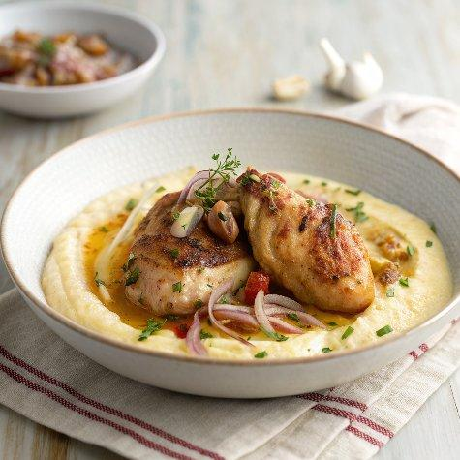

INGREDIENTS  - 2 tbsp olive oil  - 6 chicken legs around 2 kg  - 1 onion finely chopped  - 3 anchovy fillets roughly chopped  - 6 garlic cloves skin removed and lightly bashed  - 3 rosemary sprigs  - small handful of thyme  - 500ml (2.1 cups) chicken stock  - 3 tbsp crème fraîche  - 25 g butter  - small handful of parsley finely chopped  - steamed greens to serve (optional)  - 1.25 L of chicken stock  - 350 g quick cook polenta  - 50 g parmesan grated | PREP  COOK  1. Heat the oil in a wide flameproof casserole dish or frying pan and add the chicken legs, in batches if needed, and brown on one side for 10 mins, then turn over and brown for a further 10 mins. Transfer the chicken to a plate. Stir the onion, anchovies, garlic, rosemary and thyme into the pan.  2. Reduce the heat to medium and cook for 10 mins with a pinch of salt. Once the onions have softened, pour in the chicken stock and return the legs to the pan. Bring to the boil, then reduce to a low heat. Cover and cook for 35-40 mins until the chicken is cooked through. Remove the legs to a plate and discard the garlic, rosemary and thyme. Stir in the crème fraîche, butter and most of the parsley, then season to taste.  3. When the chicken has 5 mins left, to make the polenta, tip the chicken stock into a saucepan and bring to the boil. Whisk in the polenta and cook for 5 mins, until thickened and bubbling. Remove from the heat, stir in the parmesan and season to taste. Serve the chicken on top of the polenta with a spoonful of sauce and scatter over the remaining parsley. Serve with steamed greens, if you like.  PLATING

