MOTHERSHIP SUNDAY ROAST CHICKEN  COOK TIME: 2h  SOURCE:  #comfort-food #roast #family-meal | 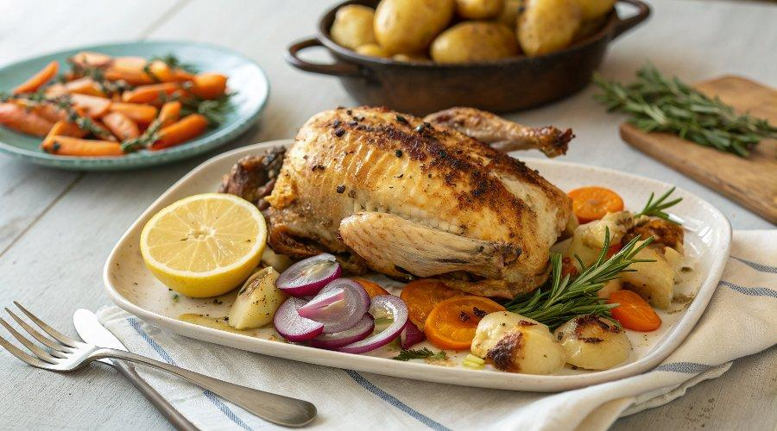

INGREDIENTS  - 1 kg potatoes  - 1 lemon  - 4 sprigs of fresh rosemary1 x 1.8 kg whole free-range chicken  - olive oil  - 500 g carrots  - 1 onion  - 2 knobs of unsalted butter  - 1 orange  - 2 sprigs of fresh thyme  - 2 cloves of garlic  - 1 heaped tbsp plain flour  - 1/2 a Savoy cabbage  - 250 g frozen peas | PREP  COOK  PLATING

