COCONUT OIL BROWNIES  COOK TIME: 35 min  SOURCE:  #chocolate #baking #sweet | 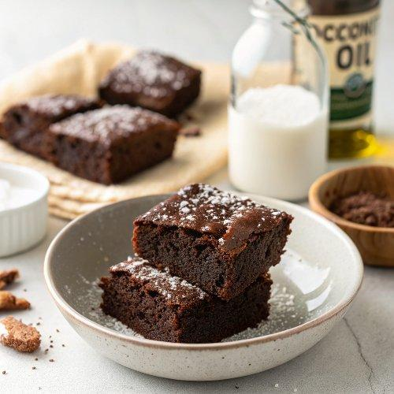

INGREDIENTS  - 4 oz (113 g) bittersweet chocolate  - 1 cup (209 g) virgin coconut oil, (measured solid)  - 1 cup (200 g) granulated sugar  - 1 cup (125 g) packed light brown sugar  - 3 large eggs plus 1 egg yolk  - 1 tsp vanilla extract  - 3/4 cup (96 g) all-purpose flour  - 1 cup (80 g) unsweetened cocoa powder  - 1/2 tsp fine sea salt  - 1/2 tsp baking soda | PREP  COOK  1. Preheat the oven to 350°F (175°C). Line an 8x8-inch (20x20cm) baking pan with foil or parchment paper, leaving an overhang on two sides.  2. In a large heat-safe bowl, combine the chocolate and coconut oil and microwave in 30-second bursts until melted and smooth. Let cool slightly before adding in the granulated sugar, brown sugar, eggs and yolk, and vanilla. Add the flour, cocoa powder, salt, and baking soda and stir until just combined. Pour the batter into the prepared baking pan and bake for about 35 minutes or until the brownies are set but moist crumbs are still attached when inserting a toothpick.  3. Let cool completely before cutting into squares and serving. These are very moist brownies and are easier to neatly slice when chilled. Store in an airtight container at room temperature for up to 3 days or in the fridge for up to 5 days.  PLATING

