SIMPLE SAUSAGE PASTA  COOK TIME: 50 min  SOURCE:  #quick #comfort-food #pasta | 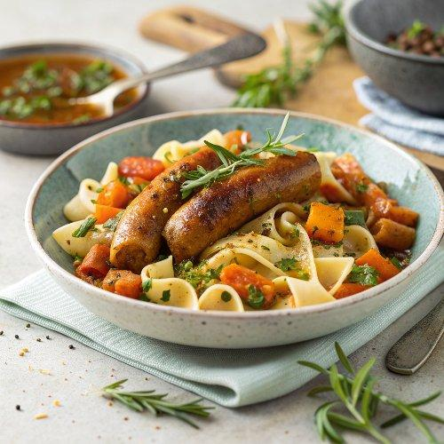

INGREDIENTS  - 4 higher-welfare pork sausages or veggie sausages  - 4 sprigs of rosemary or 2 tsp fennel seeds  - 2 cloves of garlic  - olive oil  - 320 g fresh or frozen chopped mixed onion, carrot & celery  - 1 x 400 g tin of chickpeas  - 2 x 400 g tins of quality plum tomatoes  - 450 g pasta shells  - optional: Parmesan cheese, for grating | PREP  COOK  1. Place a large shallow casserole pan on a medium-high heat. Squeeze the sausage meat out of the skins into the pan, breaking it up with a wooden spoon and fry until lightly golden, stirring regularly. (If using veggie sausages, roughly slice and fry in 1 tablespoon of olive oil until golden and crispy.)  2. Pick and roughly chop the rosemary leaves and peel and finely slice the garlic. Drizzle 1 tablespoon of oil into the pan then add the chopped mixed veg, rosemary and garlic. Season to perfection, then mash everything together with a masher and cook for 10 minutes, stirring occasionally, until softened.  3. Pour in the chickpeas, juice and all, and scrunch in the tomatoes along with 1 tin’s worth of water, mashing everything up until fine. Bring to the boil, then reduce to a medium-low heat and simmer for 30 minutes, until thick and delicious, mashing everything up with a potato masher.  4. When the sauce has around 12 minutes remaining, cook the pasta in a pan of boiling salted water according to the packet instructions, then drain, reserving a mugful of the starchy cooking water.  5. Toss the cooked pasta into the sauce, adding splashes of the water to loosen if needed, then divide between bowls. Grate over a little Parmesan and drizzle with a little olive oil, if you like, and serve.  PLATING

