FOUR HERBS SOUP (SI SHEN TANG - 四神汤)  COOK TIME: 2h 30m  SOURCE:  #comfort-food #hearty #traditional | 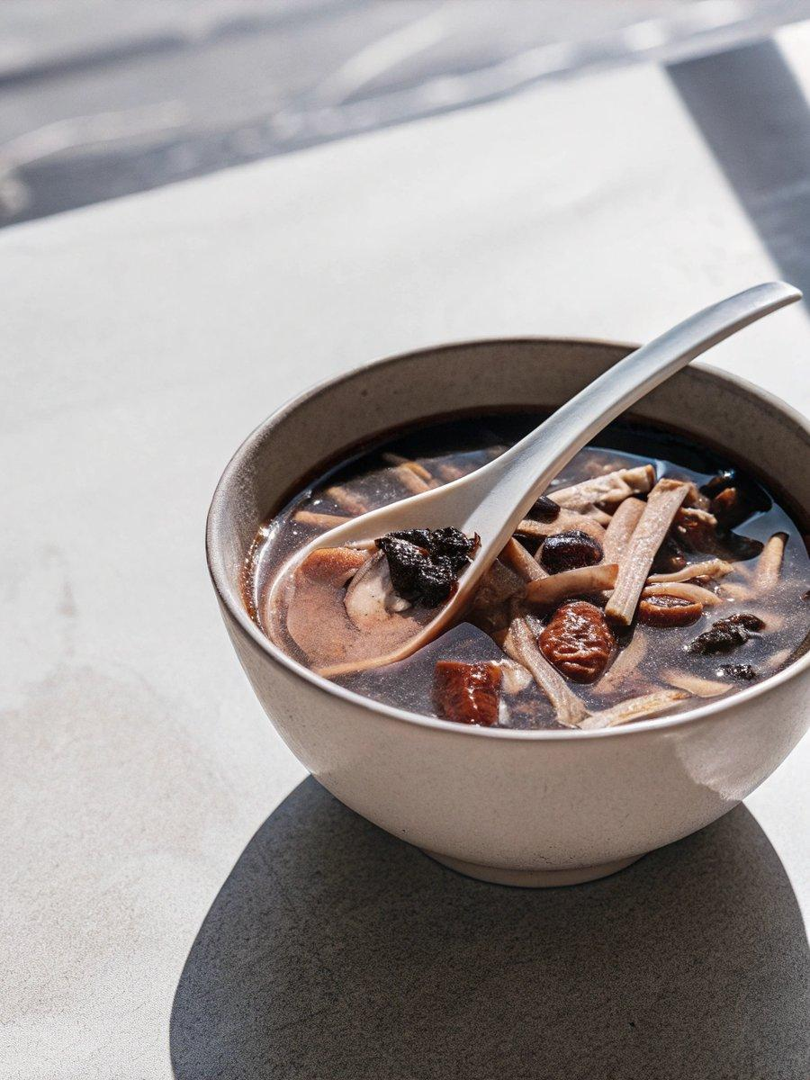

INGREDIENTS  - 30 g dried fox nut barley (芡实, qiànshí)  - 25 g dried lotus seeds  - 30 g dried Chinese yam slices (山药, shānyào)  - 35 g poria cocos mushrooms (苻苓, fú líng)  - 2 lb pork neck bones (or 100 g dried soybeans as a vegetarian option)  - 5 slices ginger ( 1/8-inch/3 mm thick and 2 inches/5 cm long) )  - 6 oz carrot (about 1 medium, cut into 1 1/2-inch (4 cm) chunks)  - 12 oz daikon radish (about 1 small, cut into 1 1/2-inch (4 cm) chunks)  - 10 cups (2400ml) water  - salt (to taste) | PREP  COOK  1. Soak the dried fox nut barley, dried lotus seeds, dried Chinese yam, and poria cocos mushrooms in a bowl with enough water so that everything is submerged.  2. Meanwhile, soak the pork bones in cold water for 1 hour. Rinse thoroughly, and drain. In a large thick-bottomed stock pot, add the pork bones and enough cold water to cover. Bring to a boil over high heat. Once boiling, immediately drain the pork bones through a colander and rinse them clean. Wash the soup pot as well. This soaking and boiling process washes away impurities and keeps the soup clear.  3. Add the pork back to the pot. Drain the dried herbs, and add to the pot as well, along with the ginger, carrot, daikon, and 10 cups (2400ml) of water.  4. Bring to a boil, then cover and reduce the heat to medium-low. The water should be moving at a slow simmer—not simmering rapidly or boiling. Cook for 2 hours.  5. Add salt to taste just before serving. We like to enjoy the meat from the pork bones with light soy sauce for dipping.  PLATING

