CHICKEN & MUSHROOM HOTPOT  COOK TIME: 1h 10m  SOURCE:  #comfort-food #hearty #one-pot | 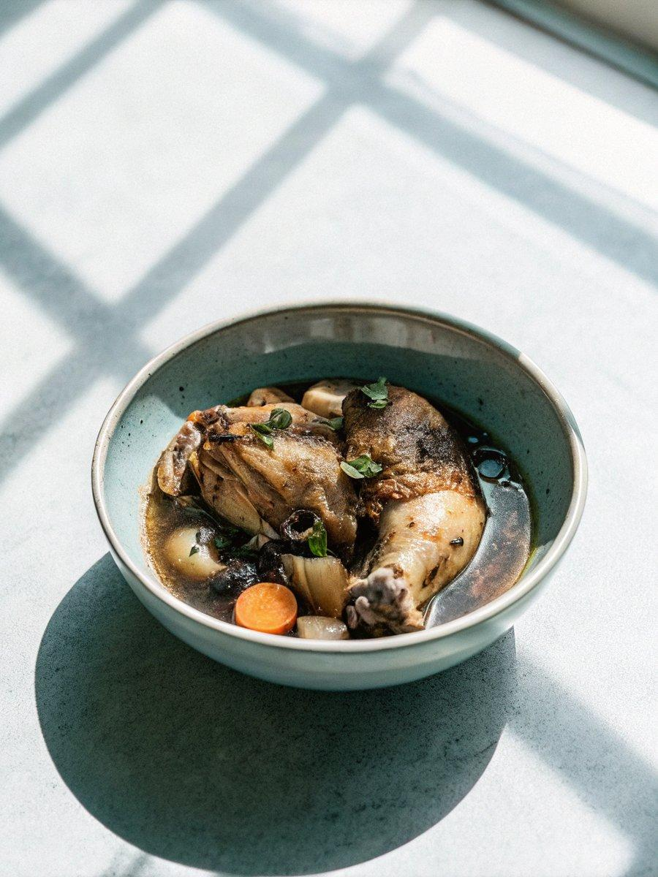

INGREDIENTS  - 4 large free-range chicken thighs, skin on, bone in  - 2 onions (320 g)  - 2 large carrots (320 g)  - 1/2 a bunch of thyme (10 g)  - 320 g chestnut mushrooms  - 1 x 295 g tin of condensed mushroom soup  - 600ml (2.5 cups) semi-skimmed milk  - 320 g frozen sweetcorn  - 1 x 570 g jar of cannellini beans  - 2 x 400 g bags of potato gnocchi  - olive oil | PREP  COOK  1. Put a large shallow non-stick casserole pan on a medium-high heat. Pull the skin off the chicken thighs and place it in the pan to render.  2. Season the thighs with a small pinch of sea salt and black pepper, and place in the pan, turning with tongs until golden all over, while you peel the onions and carrots and chop into 3cm (1-inch) chunks, adding as you go. Remove and discard the crispy chicken skin, then strip in the thyme, tear in the mushrooms, and cook for 20 minutes, or until the veg is caramelized, stirring regularly.  3. Now, stir in the soup and milk. Cover with a lid ajar, and simmer gently on a medium heat for 10 minutes. Preheat the oven to 220°C/425°F (220°C)/gas  7.  4. Stir the sweetcorn and beans, juice and all, into the pan, then gently drop the gnocchi on top. Spritz with a little olive oil, then transfer uncovered to the oven for 30 minutes, or until the chicken pulls easily away from the bone, the gnocchi are golden and the stew is bubbling nicely.  PLATING

