ARUGULA SALAD WITH BACON, TOMATOES & BUTTERMILK DRESSING  COOK TIME: 5 min  SOURCE:  #quick #healthy #comfort-food | 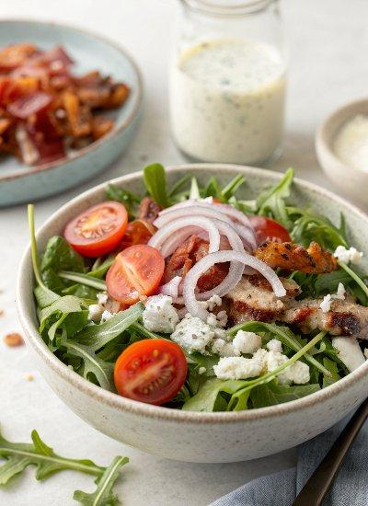

INGREDIENTS  - fresh baby arugula  - crumbled cooked bacon  - cherry or grape tomatoes, sliced in half  - red onions, sliced thinly  - blue cheese, sliced or crumbled  - buttermilk dressing (see below)  - 1/2 cup well-shaken buttermilk  - 2 Tbsp. plain Greek yogurt or mayonnaise  - 2 Tbsp. cider vinegar  - 1 clove garlic, smashed or minced  - 1/2 Tbsp. sugar  - 1/4 tsp. freshly-ground black pepper | PREP  COOK  1. To Make Salad:  2. Toss ingredients together with dressing until combined.  3. To Make Buttermilk Dressing:  4. Whisk together all ingredients until well-blended.  PLATING

