MISO ROASTED ACORN SQUASH + POMEGRANATE SALAD W/WAFFLED CHEDDAR APPLE + TAHINI GRILLED CHEESE TRIANGLES.  COOK TIME: 30 min  SOURCE:  #healthy #seasonal #salad | 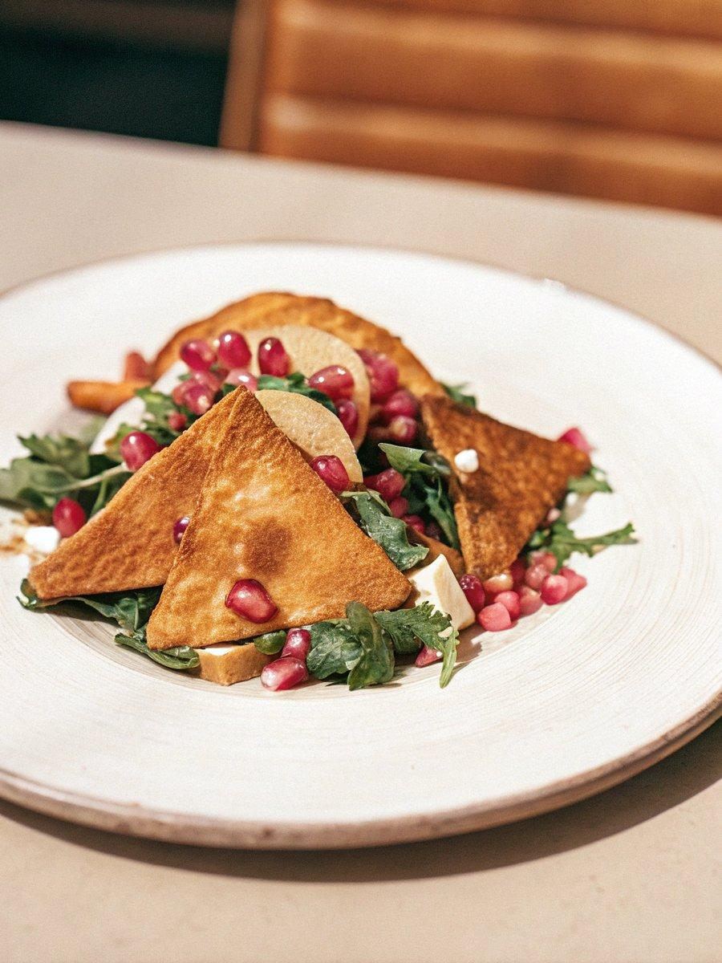

INGREDIENTS  - 1 in medium acorn squash (sliced 1/2-inch thick rounds and seeds removed)  - 1 tbsp molasses  - 1 tbsp rounded white miso  - 2 tbsp maple syrup  - 2 tbsp coconut oil (melted)  - black pepper (to taste)  - 6 cups (1440ml) baby kale  - 1 tbsp sesame seeds  - 2 tbsp parmesan cheese  - 2 cups (480ml) pomegranate juice  - 1/4 cup molasses  - 1 tbsp rice vinegar  - 1/4 cup sesame oil  - 1-2 tsp hot chile sesame oil  - 1 tbsp fresh ginger  - 1/2 tsp salt and pepper  - arils from one pomegranate  - 2 tbsp buter  - 2 sesame seed bagels  - 4 slices sharp cheddar cheese  - 1/2 slice a small green apple (thinly)  - 1/4 cup tahini | PREP  COOK  1. Preheat the oven to 425°F (220°C).  2. In a large bowl whisk together the molasses, white miso, maple syrup and melted coconut oil, add a pinch of pepper. Next add the sliced acorn squash, toss well to coat. Spread the squash out in a single layer on a baking sheet. Roast until squash is tender and starting to caramelize, 35 to 45 minutes, flipping the squash halfway through cooking.  3. Meanwhile make the dressing. Add the pomegranate juice to a small sauce pan and bring to a boil. Simmer for 15 minutes or until the juice is reduced to about 3/4 cup. Remove from the heat. Add the molasses, vinegar, sesame oil, hot chile sesame oil, fresh ginger, salt and pepper. Whisk to combine and taste, adjust to your liking. Stir in 1/4 cup pomegranate arils.  4. Once the squash is done cooking, preheat your waffle maker to medium-low heat (or use a griddle/skillet). Butter the outside of you bagels. On the inside, add a slice of cheddar, a few slices of apples and a drizzle of tahini. Add another slice of cheddar and then the top half of the bagel. Repeat with the other bagel. Add one bagel at a time to the waffle maker, slowly pressing it down as it cooks. Cook about 2-3 minutes or until the bagel is lightly crisped. Repeat with the remaining bagel.  5. Divide the kale among plates. Sprinkle with remaining pomegranate arils and drizzle with the dressing. Add the roasted squash. Slice each bagel into quarters and place over top of the salad. Drizzle with more dressing if desired. Eat while warm!  PLATING

