MASTER BAKERY STYLE MUFFIN RECIPE  COOK TIME: 30 min  SOURCE:  #quick #comfort-food #baked | 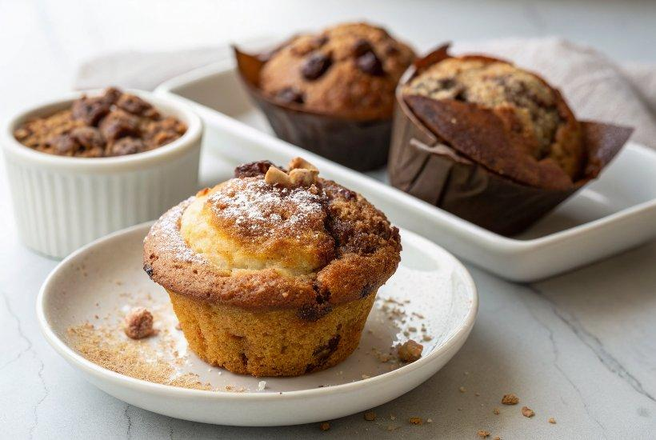

INGREDIENTS  - 3 cup (720ml)s (375 g) all-purpose flour (spooned & leveled)  - 3 tsp baking powder  - 1/4 tsp baking soda  - 1/2 tsp salt  - 1 tsp ground cinnamon (optional)  - 1/3 cup (5 Tbsp; 71 g) unsalted butter, melted and slightly cooled  - 1/3 cup (80 ml) vegetable oil*  - 1 cup (200 g) granulated sugar  - 2 large eggs, at room temperature  - 1/3 cup (80 g) sour cream or yogurt, at room temperature*  - 1 cup (240 ml) milk, at room temperature*  - 1 tsp pure vanilla extract  - 1-2 cups (480ml) add-ins (see blog post above for suggestions)  - optional: coarse sugar for sprinkling | PREP  COOK  1. Preheat oven to 425°F (218°C). Generously grease a 6-count jumbo muffin pan with butter or nonstick spray (nonstick spray recommended) or line with muffin liners. Set aside.  2. Whisk the flour, baking powder, baking soda, salt, and cinnamon (if using) together in a large bowl. Set aside.  3. Whisk the melted butter, oil, sugar, and eggs together until combined. Then whisk in the sour cream, milk, and vanilla extract. Mixture will be pale yellow. Pour wet ingredients into dry ingredients and fold together with a rubber spatula or wooden spoon until completely combined. Use a whisk to rid any large lumps of flour, if needed. Avoid overmixing. The batter will be thick. Fold in the add-in(s).  4. Divide batter between each muffin cup, filling all the way to the top. Sprinkle with coarse sugar (for added crunch, recommended!). Bake at 425°F (220°C) for 5 minutes, then, keeping the muffins in the oven, reduce the oven temperature to 350°F (177°C) and continue to bake for 25-30 minutes or until the tops are lightly golden brown and centers are set. Stick a toothpick in the center of a muffin to test for doneness. If it comes out clean, the muffins are done.  5. Allow to cool for 10 minutes in pan before serving.  6. Cover leftover muffins and store at room temperature for 5 days or in the refrigerator for 1 week. Muffins freeze well for up to 3 months. Thaw in the refrigerator or on the counter.  PLATING

